**INCLUSIVE CLASS PARTICIPATION**

**Elizabeth Cohn, American University. v 7.0**

This handout offers 25 strategies for more inclusive class discussion, 10 ways for students to participate that go beyond speaking in class, and 5 ways for you to communicate your expectations to students about participation.

**CLASS DISCUSSION**

**Twenty-five Strategies for Inclusive Discussion in the Classroom**Guidance for Students and Setting Expectations

1. Give specific guidance on your syllabus about what’s expected in a class discussion and for class participation. Create a rubric and discuss it with your students in class. Or, you can have students meet in small groups to create a rubric, and then put key elements on the board. Then hand out yours and edit as necessary to incorporate the thinking of students in the course.
2. Use [Villanova’s rubric](http://www46.homepage.villanova.edu/john.immerwahr/TP101/EvDay/discussion%20rubric.pdf) for class participation: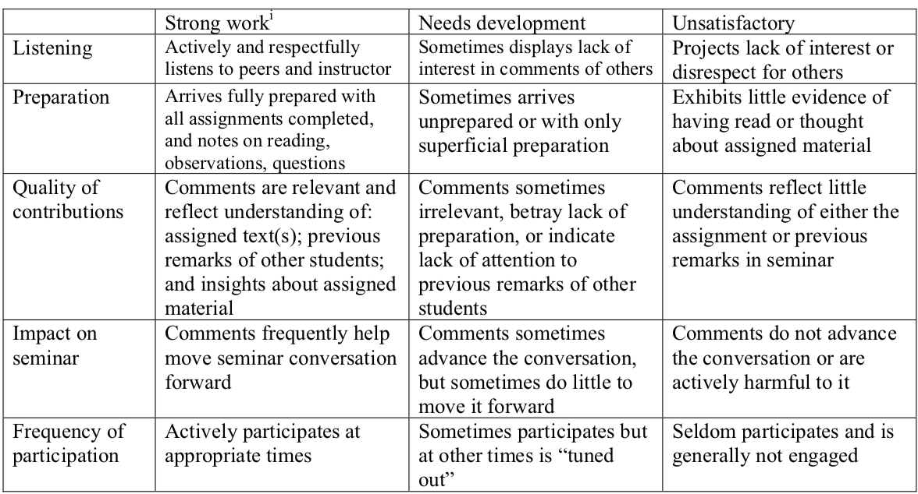

Please note that on the rubric, preparation, listening, quality of contributions, and impact on seminar come before frequency of contributions. Also note that frequency of contributions means at appropriate times. Because many students equate frequency with strong participation, I tell students that speaking too often will negatively affect their participation grade. This helps quiet students who dominate class discussion, and create space for others to speak in class.

1. On a written form at the beginning of the semester, ask your students to explain their learning style. Some people process information by listening, others by speaking aloud. Some students have anxiety, which makes speaking in groups difficult for them. One student told me that when they know the professor will call on them, they get so nervous they stop listening. If our intent is student learning, then cold calling on that student is counter-productive.
2. Talk to your students about what creates an ideal class discussion. What’s the professor’s role? What’s the student’s role? Ask them to tell you what you can do to support them, and what they will do to engage in class discussion.

Physical and Psychosocial Conditions

1. Move the desks/chairs into a circle or U shape (if feasible) so that everyone can see each other when speaking.
2. Be aware of who is speaking in your classroom, and who is not. Are the same students dominating each class session? Make a conscious decision to not allow those patterns to continue.
3. Surround your questions with silence. Wait ten seconds (you’d be surprised how long that is!) before you call on anyone after asking a question. Be comfortable with silence.
4. Create an informal tone in class, with less pressure for students to speak. Some faculty call on students directly (cold calling), to create a high-pressure environment. I find this inhibits participation and adds to already high levels of anxiety among our students.
5. Affirm comments from students. And be gentle when correcting student misstatements. For example, say “I could see how you might draw that conclusion, but let’s think some more on this…” or “I’m so glad you said that, because that’s a common misunderstanding of x and I’m sure others might be thinking this.”
6. Use the pronouns that students identify for themselves. On my student information form I ask: “Personal Pronouns. Pronouns are used to replace someone's name in a sentence and often are related to the gender of an individual. For example, they/them/theirs, she/hers/her, he/him/his. Please let me know which of these you go by.”

Increasing the Number of Students Who Speak in Class

1. Ask a question, then have students jot down their thoughts for 1-3 minutes. This is key for students who aren’t quick thinkers, so they have time to gather their thoughts. I call this Pause to Reflect or P2R. See my handout “Ten Active Learning Exercises to Complement a Lecture.”
2. Ask a question, wait for hands to go up, be silent for a moment, then say “based on the readings” and often the most talkative students will lower their hands, giving space for those who have done the reading to talk.
3. Give questions in advance on the syllabus or Canvas one week before students are required to do the reading. This allows students to be active readers and have time to think through issues. Then use those questions in class. Students tell me this is key
4. For a non-seminar class where students might think that speaking isn’t expected, begin class by saying, “Everyone gets to talk today. Nobody can speak twice until everyone has spoken once.” Then you must abide by that instruction.
5. Hold small group discussions in class. This allows more people to talk, particularly ones reluctant to speak in large groups.
   1. Walk around while group discussions are happening and listen for insightful remarks from students who don’t usually speak. Tell them “That’s a great point.” And ask if you can call on them when the class reconvenes. My students have always welcomed the opportunity. Affirming the comment before they state it to the whole class instills confidence.
   2. Ask a few of the small groups to share insights or questions when the class reconvenes.
   3. Alternatively, rather than oral reports after small group discussions, ask one student from each group to be the recorder, and have them post their group’s comments (with or without individual attribution) to a Google doc. (During the discussion use Canvas to email all students a link to a Google doc.) Then have all students read the Google doc in silence (which is quite refreshing), and you or the students can take the discussion where it needs to go.
6. Have students call on each other, instead of having the professor call on students to speak. This allows you to withdraw from the discussion until the end, and often has the effect of changing a class dynamic to create space for those who are more reluctant to speak in class. Faculty tell me this has led to much more inclusive participation.

Techniques for Specific Types of Students

1. For international students, allow them to speak first in their native language and then have them translate for the class. (I have done this with international students who I could see had something to say but were silent, and then they spoke more frequently.)
2. For students who frequently raise their hands immediately after a question is asked, 1) acknowledge them, 2) ask for a volunteer who hasn’t had a chance to speak, or 3) ask the initial student to write down what they want to say. You can either call on them later or don’t call on them and ask them after class what they wanted to say.
3. Speak privately to talkative students to reassure them that you value their contributions and that you want everyone in the class to have the opportunity to speak in class. Tell them they may speak in class no more than three times during a class session, and if they have more to discuss you are happy to engage with them during office hours.
4. Speak privately to students who are reluctant to speak, to reassure them that the classroom is a place for learning, and that includes speaking in groups. Remind them that they are always welcome to pass if called on, but that speaking in groups is a skill they will need for work.
5. If you expect discussion to be based on the readings, make sure to have readings available for low or no cost. This will allow students who can’t afford to buy the texts to still be prepared for class and contribute to class discussion.
6. When a student presents an unpopular/controversial view, it is important to not allow the majority to shut down that student or the conversation. Instead, claim the view as worthy of examination and write the view on the whiteboard. This moves the focus from that one student to the idea. Ask all students: “Why might someone think this? What are the assumptions behind this point of view? What is an alternative way of looking at this issue?”

Valuing and Assessing Class Discussion

1. Value what is said by a student by reminding students that everything said in class – not just what the professor says – is worthy of attention and note-taking. And when someone says something particularly insightful, ask students “Did everyone get Karla’s point? Or do you need Karla to repeat it?” Resist the temptation to repeat Karla’s point yourself – which only reinforces that students should listen only to what you state. Wait in silence until a student asks Karla to repeat the point. You may have to do this several times until students learn to listen carefully to their classmates and take notes on what they are saying. You can ask for volunteers to summarize Karla’s point in their own words.
2. Have students take handwritten notes instead of on laptops. This will bring everyone’s attention to the classroom and away from on-line distractions. Since we can’t ban laptops, as some students require them for their learning, try a policy of “laptops up, laptops down.” (See my syllabus language below.) I allow any student to request using a laptop during class for notetaking (so as not to ‘out’ students with accommodations) but many of my students use laptops in class only when we need to read an article posted to Canvas.
3. Check in with your students periodically about whether they feel included in class discussion. A survey should be anonymous to elicit honest answers. You might ask, as [Stephen Brookfield](https://www.stephenbrookfield.com/critical-incident-questionnaire) does: “At what moments did you feel you mattered? At what moments did you feel marginal?”

**ALTERNATIVES TO CLASS DISCUSSION  
  
Ten Ways for Students to Participate Apart from Speaking in Class**

You may also want to re-evaluate what student behaviors – beyond speaking in class – should comprise participation.

1. Use technology, such as [Poll Everywhere](https://www.polleverywhere.com/) or [Mentimeter](https://www.mentimeter.com/) to have students answer questions in class. This is particularly good for eliciting honest answers for sensitive topics or to assess comprehension of a lecture or reading. It assesses comprehension of the group, but not of individuals because responses are anonymous.
2. Use Google docs, asking students to contribute to them before a class session. This is most effective if students are assigned different questions to answer, which collectively address a topic. Class time can be used to work with that material, depending on your learning goals.
3. Use unannounced in-class writing assignments at the beginning of class to give you data on student engagement with the reading. Ask one question, preferably one of the reading questions given in advance (see #13 above), and give students five minutes to answer. Collect and return with a grade. This allows students who don’t want to speak in class to demonstrate engagement with the reading. In classes of 25-35 students I have done one per week, and at the end of the semester this data is calculated into the student’s participation grade. It has the added benefit that students do the reading so you don’t have to lecture on it. I allow students to use their reading notes, as my point is engagement with the reading and inclusivity. Be sure to make accommodations for students who are allowed extra time on assignments or use a laptop for note-taking.
4. Rather than a general class discussion, try a specific active learning exercise such as Think-Ink-Pair-Share; Brainstorming; Draw-it!; Super-sentence; One-minute lecture; Fishbowl; and other ideas on my handout “Ten Active Learning Exercises to Complement a Lecture.”
5. Assign roles for discussion – expert, investigator, critic, etc. so that students can role-play.
6. For many exercises to do in class, see Gail Taylor Rice, [*Hitting Pause*](https://styluspub.presswarehouse.com/browse/book/9781620366530/Hitting-Pause)*: 65 Lecture Breaks to Refresh and Reinforce Learning*. Sterling, VA: Stylus, 2018.
7. Have students post their comments about course material to Canvas on a discussion thread. I call this “Read, Think, Write” or RTW. You can require this to be submitted before class so they can engage the readings and you can see what points need clarification or amplification, and after a class session to allow students to demonstrate further learning.

However, with the advent of generative AI, it is too easy for AI to complete this assignment, and many argue the discussion board is dead. Alternatively, you can use tools such as [Perusall](https://www.perusall.com/) and [Hyphothes.is](https://web.hypothes.is/) to have students engage with readings by annotating a text with specific comments or to respond to each other or your queries.

1. I have a colleague who asks students to show them their notes on the reading before class. This can be a Ticket-In-The Door (TID).
2. Ask for one IQDC – Interesting Question or Devastating Critique – on the reading as a TID as one of my colleagues does.
3. Use a Ticket-Out-The-Door (TOD) at the end of class. This requires students to: 1) reflect on their class participation based on the class rubric; 2) grade themselves on class participation (which I override if necessary, but after a few times the numbers often match); and 3) write down insights they might not have shared in class (which count toward their participation grade). This can be done on Canvas. My TOD is:  
   “NAME DATE  
   1) Based on the participation rubric for this course, what participation grade would you give yourself for today’s class? GRADE: ____ (Based on scale of 0-100) Why?   
   2) What still puzzles you about the material we covered in class today? (Nothing is a possible answer)   
   3) What one insight did you have today? Or any other comments?”

**FIVE WAYS TO COMMUNICATE YOUR EXPECTATIONS TO STUDENTS**

1. Write expectations in your syllabus, perhaps using a rubric, and discuss at the start of the semester to emphasize the elements of engagement you value and assess. It is essential that students know how they will be evaluated, as every professor has different criteria.
2. Model in class. Praise the students who are engaging in ways you value.
3. Give feedback addressing different modes of engagement with a Ticket-Out-The-Door (TOD) for the first few weeks or periodically. Doing this every class will be taxing on your time, but you may prefer to do it every week.
4. If you do not use a TOD, provide early warning to students who are not engaged at the level you think they should be, so that they may improve throughout the semester or decide to withdraw from your course before the final drop deadline. (This and #5 below also reduce grade grievances.)
5. Give each student a written mid-semester participation report or grade – even if you don’t include participation in their final grade – so they know if they are meeting your expectations.

(Continued)

**Elizabeth Cohn Syllabus Language on Technology-in-the-Classroom Policy**

Laptops and tablets in the classroom can be a tool for learning or a distraction. Since we have only 75 minutes together for each class session, this is an opportunity to unplug from our daily feeds and interactions online so that we can focus on each other and the important themes of this course.

Given the large number of readings on Canvas, and the fact that we will be referring to readings during class discussion, my laptop policy is “laptops up, laptops down.” This means that for most of you, your laptops will be closed most of the time. You should plan on writing class notes by hand in a notebook, not on your computer. Why this policy?

Studies show that [taking notes by hand](https://www.scientificamerican.com/article/a-learning-secret-don-t-take-notes-with-a-laptop/), rather than on a laptop, increases student learning because you must process what is important and write only the significant points, though [later studies](https://www.learningscientists.org/blog/2019/2/21-1) showed that the difference in learning was negligible. Taking notes on a computer leads to the temptation of typing everything, and can result in a transcript of the class session rather than an understanding of key concepts, and it can also [negatively impact](https://www.nytimes.com/2017/11/22/business/laptops-not-during-lecture-or-meeting.html) those sitting near you.

In addition, attachment to our devices is [addictive](https://www.washingtonpost.com/outlook/2021/07/19/social-media-addiction-social-science/) and can lead to [stress](https://www.ncbi.nlm.nih.gov/pmc/articles/PMC6515762/) that interferes with learning. Further, multi-tasking during class on your laptop, texting, and any use of cell phones is disruptive to the learning environment. Multi-tasking isn’t actually possible; studies show we are [task switching](https://www.inc.com/scott-mautz/psychology-and-neuroscience-blow-up-the-myth-of-effective-multitasking.html) – which means you’ve stopped paying attention to class if you’re checking Instagram or email. (I know since I’ve done it in meetings.)

I do understand that some students learn best by using a laptop in class to take notes. This includes, but is not limited to, students with accommodations. Thus, the use of laptops or tablets for taking notes during class is allowed by special arrangement with me.

Before you ask for a laptop contract (see below), think about what will enhance your learning and whether you will be distracted by using your laptop in the classroom. Any student who uses their electronic devices for non-class purposes will receive one warning and then lose the right to use their laptop in class.

Any student who needs a laptop or tablet for learning should write up a contract, and email it to me, that states:

I [NAME] need a laptop for learning in the classroom for the following reason(s) [REASON(S)]. I will use my laptop in class only for the purpose of taking notes, and if I violate this contract, I understand that I will be given one warning and after a second violation, lose the right to use my laptop in class.

If you find yourself bored or distracted, let’s talk about what you, or I, can do to focus your attention in the classroom.