Theories of Violence and War
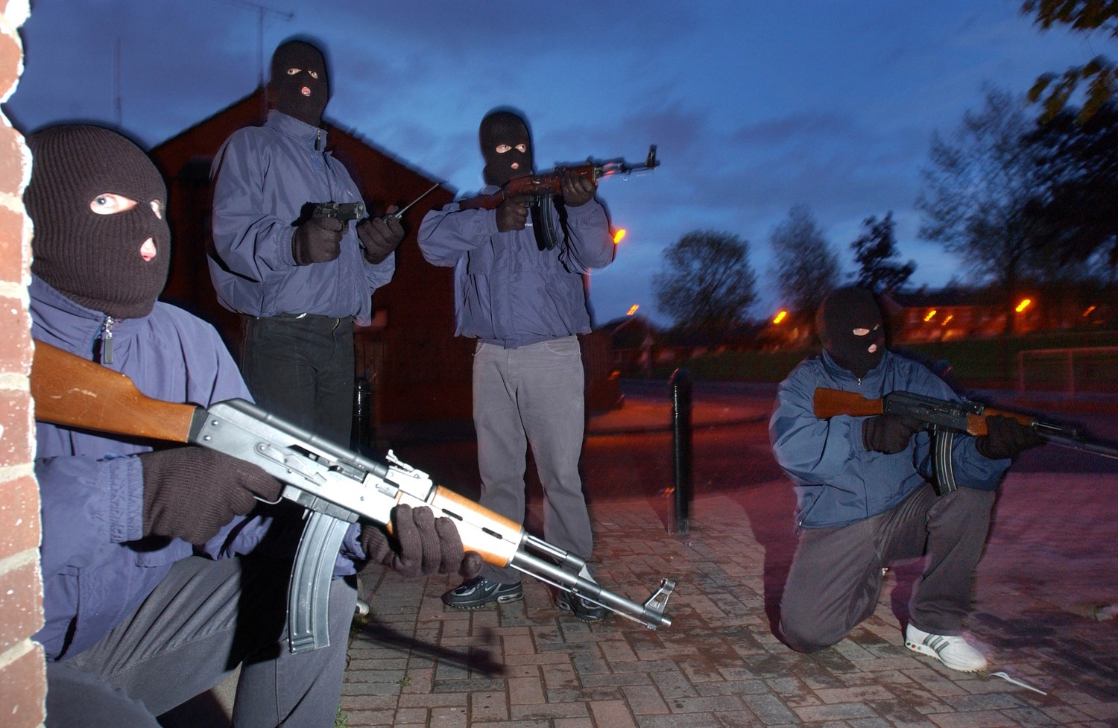
Loyalist Paramilitary punishment ‘squad.’ Steven McCaffery, 25 June 2015. The Detail
SIS 610-003

Dr. Carolyn Gallaher
SIS 324
202.885.1827
caroleg@american.edu

Office Hours: Tuesday: 10am-2pm
Friday: 2:30-4:30 pm
Other hours by appointment

REQUIRED TEXTBOOKS
- Violence: A Reader. Edited by Catherine Besteman. 2002. New York University Press.
- After the Peace: Loyalist Paramilitaries in Post-accord Northern Ireland. By Carolyn Gallaher. 2007. Cornell University Press.
- Blackboard Reader: Other readings for this class will be posted on the blackboard site.

COURSE DESCRIPTION:
This course introduces students to the main theoretical frameworks through which we explain the outbreak of war/conflict as well as the nature of violence in them. These theories are pitched at a variety of scales—the global, national, local, and individual levels—and come from a variety of disciplines, including anthropology, geography, political science, and sociology, among others. In this class we will unpack these theories and apply them to specific case studies. As such, while the focus of the class is theoretical, you will be given an opportunity to apply the theories discussed in class to actual wars/conflicts.

This course is divided into 3 parts. In the first part of the class we will discuss the difficulty of doing research in conflict zones and collecting usable data from them. Many of you may go on to jobs that require you to collect conflict data, so understanding the limitations of data collection in conflict zones is important. In the second and largest part of the class, we will discuss the main theories used to explain violence and war. In particular we will review the following schools of thought:

● State-centric approaches ● Environmental Scarcity
● Marxism ● Ethnicity and Identity
● New war theory ● Biological explanations
● Critical Terrorism

In the third part of the class we will apply these theoretical lens to two case studies—Loyalist paramilitary violence in Northern Ireland and drug cartels in Mexico.

LEARNING OUTCOMES:
At the end of this course students will:
- Be conversant in a variety of theoretical explanations for violence and war
- Be able to apply the theories we cover in this class to conflicts not discussed in it
- Be familiar with the different scales of analysis used to study conflict.
- Be able to identify benefits and shortcoming of the theoretical models discussed in class
- Respect the different disciplinary traditions that frame the study of violence and war.
- Learn to write about violence/war in clear, analytically cogent prose.

EVALUATION:
Assignments:
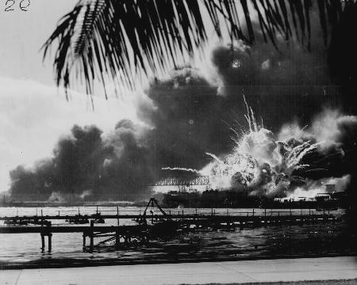
Japanese bombing Pearl Harbor. Photo Credit: Us Archives
- Thought Piece 1 22%
- Thought Piece 2 22%
- Thought Piece 3 22%
- Final Exam 22%
- Group Presentations 12%

Thought Pieces: Students will write 3 thought pieces during the semester. Students will be asked to grapple with the theories we read in this class, assessing their strengths and weaknesses as well as how competing theories align and diverge.

Final Exam: Students will complete an in-class essay exam in which they answer questions about the broad array of theories/approaches used to explain violence and war.

Group Presentations: I will put students into small groups on the 2nd day of class. Each group will be responsible for 2 in class presentations. More details on specific presentation topics will be discussed during the course of the semester.

Grading Scale:
A 95-100 B+ 87-89 C+ 77-79 D 60-69 F < 59
A- 90-94 B 83-86 C 73-76
B- 80-82 C- 70-72

A=excellent work, B=good work, C=satisfactory work, D=unsatisfactory work, F=inadequate work

CLASSROOM RIGHTS AND RESPONSIBILITIES:
- Be On Time: Coming to class late is better than not coming at all. However, you may also miss critical information about upcoming assignments. It is the student’s responsibility to catch up on missed material. I do not share my lecture notes or give individual lectures in my office.
- Cell Phones Off: Turn off cell phones in class. This means no texting during class.
- No Laptops: Laptops provide students with too many distractions (email, social media, bargain hunting, etc.). Even the most attentive students can get distracted by all of this. Exceptions are only granted to students with a documented learning disability.
- Keep email to a minimum: Email is not the best way to communicate with your professors. Whenever possible you should communicate with me in person during my office hours or by phone.
- Proper Notification: Students are entitled to miss exams and assignment due dates for the reasons listed below. In each case, students must provide proper documentation. All other cases will result in zero credit for a missed assignment/exam.
Religious holidays Illness requiring a doctor’s visit Car Wreck
Surgery Death in the family
- Open Dialogue: During the semester unexpected problems may affect your performance in this class. I am willing to work with you to overcome any such difficulties. I can only do so, however, if you let me know WHILE something is affecting you. Please feel free to keep me abreast of issues as they occur rather than coming to me at the end of the semester with an explanation for poor performance. At that point it is usually too late for me to do anything to help you.
- Academic Integrity: Standards of academic conduct are set forth in the University's Academic Integrity Code. By registering, you acknowledge your awareness of the Academic Integrity Code, and you are obliged to become familiar with your rights and responsibilities as defined by the Code. Violations of the Academic Integrity Code will not be treated lightly, and disciplinary actions will be taken should such violations occur. Please see me if you have any questions about the academic violations described in the Code in general or as they relate to particular requirements for this course. I also encourage you to familiarize yourself with the AIC code found at http://www.american.edu/provost/registrar/regulations/reg80.cfm.
- Emergency Preparedness: The University maintains a webpage with useful information about what the university will do in the event various emergencies, including weather events (e.g. tornadoes), direct threats (e.g. active shooters), and health crises (e.g. pandemics). Students should sign up for the AU alerts program to keep abreast of any problems on campus. They may also check blackboard or their email for notifications about how a given emergency affects scheduled classes as well as assignments. The AU website for emergency preparedness can be found at:
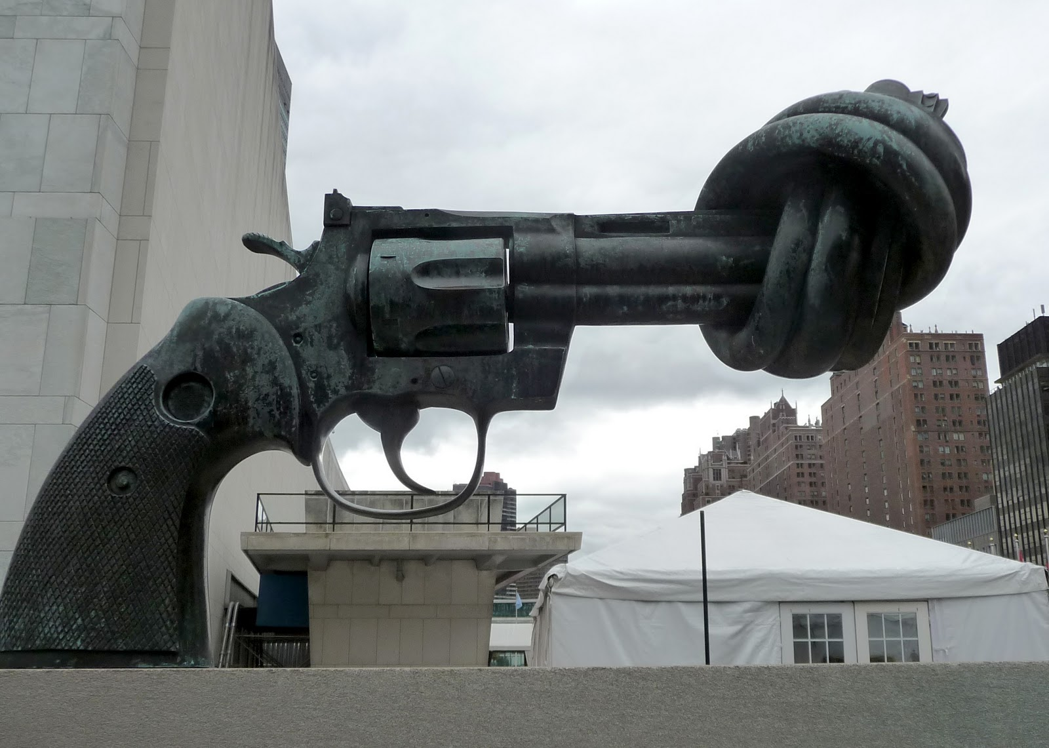
Sculpture by Carl Fredrick Reuterswärd, photo by Luis Bastardo.
http://www.american.edu/emergency/

SECTION 1: LEARNING TO STUDY WAR

8/30 | Getting Started: Why is Theory Important for Analyzing Violence?  Part 1: Getting to Know Each Other  Part 2: Syllabus Review  Part 3: Why Do We Need Theory?
9/6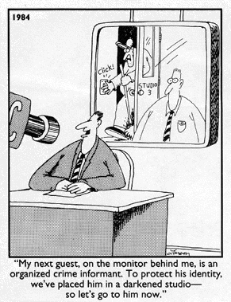  Gary Larson, The Far Side | Studying War—‘This Ain’t No Cakewalk!’  Part 1: Analytic Issues  - Blackboard 1: Stathis Kalyvas. 2006. The Logic of Violence in Civil War. Cambridge. Chapter 2  Part 2: Methodological Issues  - Blackboard 2: Carolyn Gallaher. 2009. “Researching Repellent Groups: Some Methodological Considerations on how to represent Militants, Radicals, and other Belligerents.” In (Sriram et al Eds) Surviving Field Research: Working in Violent and Difficult Situations. Routledge.  - Blackboard 3: Lee Ann Fuji. 2009. “Interpreting Truth and Lies in Stories of Conflict and Violence.” In Surviving Field Research  - Blackboard 4: Amy Ross. 2009. “Impact on Research of Security-seeking Behavior.” In Surviving Field Research
SECTION 2: COMPTETING THEORIES

9/13 | The Role of the State  Part 1: War as something States do  - Violence-a Reader, Chapter 4 (Charles Tilly: “War Making and State Making as Organized Crime”)  Part 2: Why Do States Wage War?  - Blackboard 5: Carl von Clausewitz. 1968. On War. Penguin Classics. Book 1, Chapter 1 and Book 8, Chapters 5-6.  Part 3: Can Clausewitz Explain Afghanistan?  - Blackboard 6: Major Frank Sobchak. 2005. Clausewitz: “On Afghanistan.” Military Review, July-August: 89-91.  - Blackboard 7: Tony Corn. 2006. “Clausewitz in Wonderland.” Policy Review. http://www.hoover.org/research/clausewitz-wonderland  Group 1
9/20 | The Role of the State, continued  Part 1: Total War?  - Violence-A Reader, Chapter 3 (H. Arendt: Reflections on Violence  - Blackboard 8: Bernard Wasserstein. 2009. “Blame the Victim.” The Times Literary Supplement. October 9th, pages 13-15.  - Violence-A Reader, Chapter 6 (Z. Bauman: on the Holocaust)  Part 2: A Case Study—the Battle of the Somme  - Blackboard 9: Martin Gilbert. 2007. The Battle of the Somme. Holt. Preface, Prelude, Chapter 3  Group 2
9/27  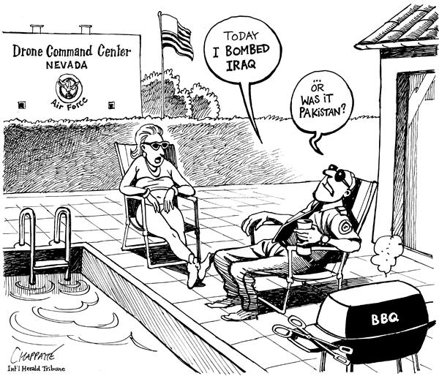 | Is There Something New about Contemporary War?  Part 1: What’s New About New War?  - Blackboard 10: Mary Kaldor. 2001. New and Old Wars: Organized Violence in a Global Era. Stanford. Chapters 1, 4, and 5  - Blackboard 11: Martin van Creveld. 1991. The Transformation of War. Free Press. Chapter 1.  Part 2: Critics of the New War Thesis  - Blackboard 12: Stathis Kalyvas. 2001. ‘New’ and ‘Old’ Wars—A Valid Distinction? World Politics, 54(1): 99-118  Part 3: Kaldor Responds  - Blackboard 13: Mary Kaldor. 2013. In Defence of New Wars. Stability: International Journal of Security and Development, 2(1): 1-16.  Paper 1 Due
10/4 | Is There Something New about Contemporary War? Continued  Part 1: Are States Really that Weak?  - Blackboard 14: Derek Gregory. 2004. The Colonial Present. Blackwell. Chapter 1.  - Blackboard 15: Žižek, Slavoj. 2002. Are We in a War? Do We Have an Enemy? London Review of Books 24(10): 3-6  Part 2: Is Warfare on the Decline?  - Blackboard 16: John Mueller. 2007. The Remnants of War. Ithaca: Cornell University Press, selected chapters.  - Blackboard 17: Forum: The Decline of War? International Studies Review 15(3): 400-405. (multiple authors).  Group 3
10/11  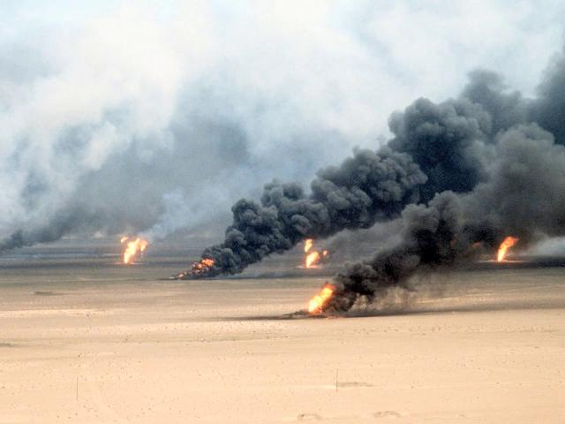  Kuwaiti Oil Fields on Fire during the first Gulf War.  Photo by: Tech. Sgt. David McLeod | Environmental Explanations  Part 1: Does Scarcity Cause Conflict?  - Blackboard 18: Jared Diamond. 2005. Collapse: How Societies Choose To Fail or Succeed. Viking Press. Chapter 10  Part 2: Or is it Abundance?  - Blackboard 19: Paul Collier, Anke Hoeffler, 2004. Greed and Grievance in Civil War. Oxford Economic Papers 56: 563-595.  - Blackboard 20: Laurie Nathan. 2005. The Frightful Inadequacy of Most of the Statistics. Track Two 12(5): 1-36  Part 3: A Case Study: Does Having Oil Contribute to Conflict?  - Blackboard 21: Jeff Colgan. 2014. Fueling the Fire: Pathways from Oil to War. International Security 38(2): 147-180.  Group 4
10/18 | Marxist Explanations  Part 1: The Role of Class in Conflict: the case of Sendero Luminoso  - Blackboard 22: Cynthia McClintock. 1984. “Why Peasants Rebel: The Case of Peru’s Sendero Luminoso.” World Politics 37: 48-84.  Part 2: A Marxist Analysis of Afghanistan and Iraq  - Blackboard 23: David Harvey. 2003. The New Imperialism. Oxford University Press. Chapters 1 and 5.  Part 3: Are Realism and Marxism Compatible?  - Blackboard 24: A.Callinicos. 2007. Does capitalism need the state system? Cambridge Review of International Affairs, 20(4)533-49.  - Blackboard 25: Gonzalo Pozo-Martin. 2007. Autonomous or Materialist geopolitics? Cambridge Review of International Affairs, 20:4, 551-563.  Paper 2 Due
10/25 | Ethnicity as a Driver of Conflict  Part 1: The Role of Ethnicity  - Blackboard 26: James Fearon, David Laiton. 2003. Ethnicity, Insurgency & Civil War. American Political Science Review 97:75-90.  - Blackboard 27: V.P. Gagnon. 1994-95. Ethnic Nationalism and International Conflict. International Security 91(3): 130-166.  Part 2: Ethnicity and Democracy  - Blackboard 28: Mohameden Ould-Mey. 1996. Global Restructuring and Peripheral States: The Carrot and the Stick in Mauritania. Rowman and Littlefield. Chapters 8 and 9  - Blackboard 29: Amy Chua. 2002. World on Fire: How Exporting Free Markets and Democracy Breeds Ethnic Hatred and Global Instability. Introduction and Chapter 6.  Group 1
11/1 | Biological Explanations  Part 1: Biological Views (and their critics)  - Blackboard 30: Margaret Meade. 1940: Warfare is only an Invention, Not a biological Necessity. Asia 40(8): 402-405.  - Blackboard 31: Rose McDermott, Dominic Johnson, Jonathan Cowden and Stephen Rosen. 2007. Testosterone and Aggression in a Simulated Crisis Game. The Annals of the American Academy of Political and Social Science 614: 15-33.  - Blackboard 32: Michael Ghiglieri. 1999. The Dark Side of Man: Tracing the Origins of Violence. Persus. Chapter 1  Part 2: Case Study—Is Rape a ‘natural’ part of war?  - Violence-A Reader. Chp 11 (R. Copelon: Surfacing Gender)  - Blackboard 33: MB Olujic. 1998 “Embodiment of Terror: Gendered Violence in Peacetime and Wartime in Croatia and Bosnia-Herzegovina.” Medical Anthropology Quarterly 12(1): 31–50.  - Blackboard 34: Elisabeth Wood. 2006. “Variation in Sexual Violence During War.” Politics and Society 34.  Group 2
11/8 | What is Terrorism, And Is It Different Than It Used to Be?  Part 1: Is the Concept of Terrorism Useful?  - Blackboard 35: Paul Wilkinson and Dominic Bryan. Is Terrorism Still a Useful Analytical Term or Should it be Abandoned? In R. Jackson and S.J. Sinclair EDs) Contemporary Debates on Terrorism. Routledge.  Part 2: Critical Terrorism  - Blackboard 36: David Martin Jones & M. L. R. Smith (2009) We're All Terrorists Now: Critical—or Hypocritical—Studies “on” Terrorism? Studies in Conflict & Terrorism 32(4): 292-302  - Blackboard 37: Priya Dixit & Jacob L. Stump (2011) A Response to Jones and Smith: It’s Not as Bad as It Seems; Or, Five Ways to Move Critical Terrorism Studies Forward. Studies in Conflict & Terrorism 34(6): 501-511.  Part 3: Is There Something ‘New’ about Terrorism?  - Blackboard 38: Alejandra Bolanos, Isabelle Duyvesteyn and Leena Malkki. 2012. Is There a New Terrorism in Existence Today? In (R Jackson and S.J. Sinclair EDs) Contemporary Debates on Terrorism. Routledge.  Paper 3 Due
SECTION 3: THEORETICAL APPLICATION. UNDERSTANDING
WAR’S NON-STATE ACTORS

11/15 | Can We Apply the New War Theory to Northern Ireland  Part 1: Background on the Northern Ireland Troubles  Part 2: Applying the New War Theory to Northern Ireland.  - After the Peace (entire book)  Group 3
11/22 | Thanksgiving Holiday. No Class
11/29  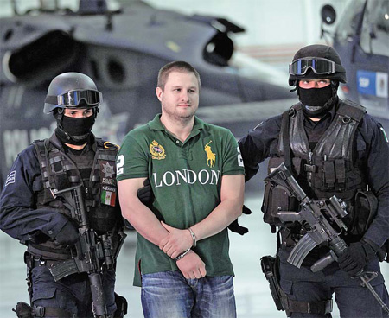  The Capture of Edgar “La Barbie” Valdez. August 31st, 2010 | Are Organized Crime Groups Terrorists? And, If So, What Does That Mean for the State? The Case of Mexico  Part 1: Background on Mexican Drug Cartels  Part 2: Are Mexico’s Cartels Terrorists?  - Blackboard 39: Morton, Adam David. 2012. “The War on Drugs in Mexico: A Failed State?” Third World Quarterly 33(9): 1631–1645  - Blackboard 40: Paul Rexton Kan, 2011. “What We’re Getting Wrong about Mexico.” Parameters Summer: 37-48  - Blackboard 41: Justin Peele. 2012. “The Case of Mexico: A Hard Pill to Swallow.” Small Wars Journal 8(4).  - Blackboard 42: Carolyn Gallaher. “Mexico, the Failed State Debate, and the Mérida Fix.” The Geographical Journal.  10.1111/geoj.12166  Group 4
12/6 | Counting the Dead  Part 1: Collecting and Using Data on War Deaths.  - Blackboard 43: Adam Roberts. 2010. Lives and Statistics: Are 90% of War Victims Civilians? Survival 52(3): 115-136.  Part 2: Final Exam Review
12/13 | Final Exam  02:30PM-05:00PM.  Exam will be administered in our regular classroom.

