Jacob Robbins
Professor Tuomi | Word Count: 1804
President Trump, Don’t build this wall
Examining Visa Overstays

WORLD POLITICS 2018
Memo
To: Donald J. Trump, 45th President of the United States
From: Jacob Robbins, Policy Advisor
Date: April 2nd, 2018
Re: Mr. Trump, Don’t Build This Wall: Examining Visa Overstays
Executive Summary
In your campaign, you pledged to crack down immigration, talking about building “a great wall along the southern border.” [13] However, you also touched on another more pressing issue than building a wall. During the campaign you mentioned that “approximately half of new illegal immigrants came on temporary visas and then never, ever left” and that under a Trump administration “visa expiration dates will be strongly enforced.” [13] In order to fulfill your campaign promise, as well as seek the more prudent solution, it is best to invest in a comprehensive entry-exit tracking system as well as a community based sponsorship program as opposed to building a wall on the southern border.
The Real Problem with Immigration
On paper, the idea of building a wall sounds simple: we do not want people coming in who shouldn’t be here, so we will build a way to keep them out. In practice, however, building a wall does not magically stop the flow illegal immigration. There are many reasons why we should not build a wall: it will be an expensive endeavor that will be arduous to construct, eminent domain proceedings, and concerns about the actual security from tunneling. The real problem, however, lies in those who come to United States legally on a short-term tourist or work visa and overstay.
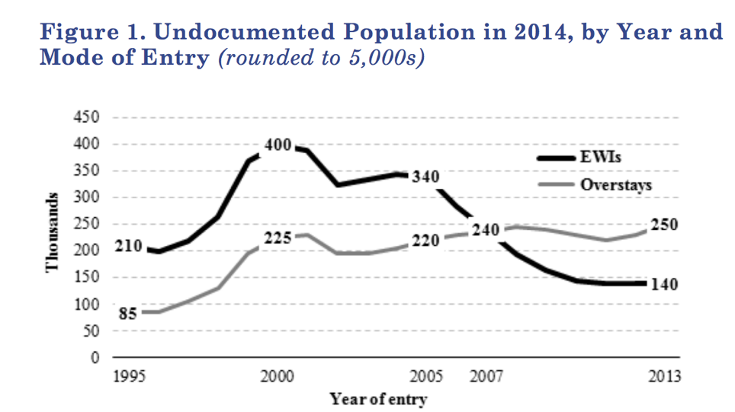
According to a report by the Pew Research Center released in 2006, roughly 45% to 50% of the undocumented population living within the United States had entered the country legally on a valid visa. [8] In 2006, according to the report, the undocumented population was estimated to be about 11.5 to 12 million and of those 4.5 to 6 million had entered the United States through legal ports of entry (seaports, airports, and checkpoints). [8] Upon arrival into the states, foreign nationals fill out what’s known as a I-94 form. The current system has the top part being collected by an immigration official upon entry and on exit from the US the bottom half is presented as a way of tracking departures [8]. In a 2003 report by the General Accounting Office, it was estimated that in 2001 20% of 1-94 arrivals had no departure record. [14] In that three year span the number of those who overstayed their visa ballooned from 20% to 45% roughly 50%.
From the Journal on Migration and Human Security

Those trends have only gotten worse. A report in the Journal on Migration and Human Security estimated that of those who acquired undocumented status in the year 2014, 2/3 had done so because they overstayed their visa. [14] The report goes on to state that since 2007 overstays have far exceeded illegal border crossings or EWIs (entries without inspections). Actually, since 2005 EWIs have been in sharp decline—overall, net migration from Mexico has been down according to a 2015 report from Pew Research Center. [6] Mexicans are leaving the US to reunite with family and the migrations are not going up. [6] A follow up report from Pew in 2017 found that Mexicans no longer make up the lion share of unauthorized immigrants. [9] More unauthorized immigrants are coming from South America and Asia rather than Mexico. [9] What’s important to note in both 2015 and 2017 reports from Pew is that this number includes those who overstay their visa, making it not a Mexico problem but rather a broad systemic issue with several countries as opposed to just one.
Importance: A Risk to National Security
Our lack of an adequate entry-exit tracking system is not only feeding into our illegal immigration problem, but poses a massive threat to our national security. That same report from the General Accounting Office in 2003 found that five of the 9/11 hijackers had exploited and overstayed their visas. [14]. That same report warns that “tracking system weaknesses make it difficult to monitor potentially suspicious aliens who enter the country legally—and limit immigration control options.” [14] 13 years later from the General Accounting Office report warning of the potential security risks associated with an inadequate entry-exit system, CBS News reported that the visa overstay loophole remains open. [12]
The 9/11 commission recommended in 2004 that the United States should construct a comprehensive biometric entry-exit system. [9] Back then they said “No one can hide his or her debt by acquiring a credit card with a slightly different name. Yet today, a terrorist can defeat the link to electronic records by tossing away an old passport and slightly altering the name in the new one.” [9] More than 10 years on from that report, the sentiment still rings true. Instead of biometric, the Government relies solely on biographic materials, the I-94 form mentioned earlier. This point cannot be underscored enough: the US has no way of tracking who is still in the country after someone enters. There is only a record of their entrance, not their exit. All of a sudden the data from Pew becomes a little scarier in light of the national security risk: most unauthorized immigrants are not coming from Mexico anymore, but rather countries in Asia and South America. [9] The U.S has only now begun to actually document through the Department of Homeland Security, but the issue still remains. [2] Something to also keep in mind: According to an Atlantic investigation, Congress passed legislation five years before 9/11 requiring a biometric identity capture system. [3] Inaction has led to attacks, making this not just a simple illegal immigration issue of economics, but also one of the utmost national importance in our security.
Why The Wall Will Not Work
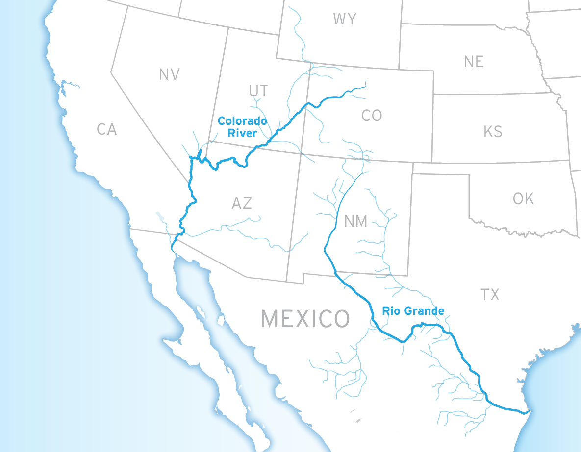
The idea of a wall sounds great, but as shown the situation is more complex. More people are entering the country legally and overstaying their visas then they are crossing the border illegally. But then there is the issue of the wall’s actual construction: it proves massively expensive. While you, Mr. President have estimated that the Wall would only cost $12 billion, the Department of Homeland Security (DHS) estimates it will cost at least $22 billion. [5] Senate Democrats own estimation ranges in upwards of $70 billion. [5] According to an analysis by The Brookings Institute, the Wall would also not prevent drug smuggling as they point out that underground smuggling tunnels can be as deep as 70ft below ground while the Wall only goes about 6ft below ground. [5] “Why the DHS believes that a 30–foot tall wall cannot be scaled and a tunnel cannot be built deeper than six feet below ground is not clear” they point out. [5] They is also the issue of the wall running through mountainous areas that are hard to cover, but also of major concern is access to the Rio Grande and Colorado River, both of which run through the US and Mexico. As Brookings points out “It wasn’t just Mexico that didn’t want that fence. U.S. farmers and businessmen along the Texas border in the Rio Grande valley opposed it, too, since it blocks their access to the river water and also augments the severity of floods.” [5] In short, the Wall would be an expensive determent that would not solve smuggling and hurt local industries of agriculture without solving the real problem: visa overstays.
From The Brookings Institute The Real Cost of a Barrier Between the United States and Mexico
Policy Options
There are three major options that exist in combatting visa overstays. The first one being discouraging visa overstay by harshening the current immigrations laws. According to a brief from the American Civil Liberties Union (ACLU), undocumented presence is only a felony and punishable in federal court if someone reenters the country after previous removal. [7] Currently, Federal immigration law is only enforced through civil proceedings not criminal prosecution--this almost always results in deportation. [7] Increasing the penalty for overstaying a visa could dissuade some considering but there are two problems with this: First, diverting federal law enforcement resources to target undocumented immigrants could actually hurt the public since most are actually less likely to commit crimes, according to the ACLU. [7] Secondly, it does not deal with those people who are already here illegally.
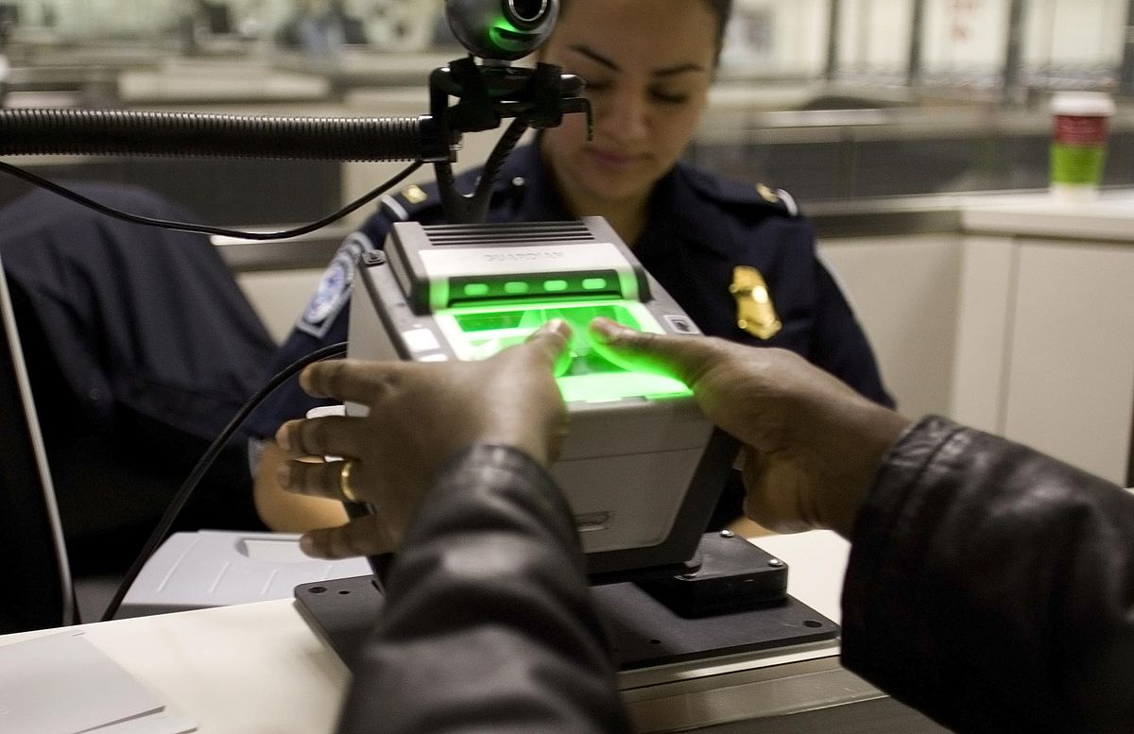
The second option would be a massive investment in a comprehensive biometrics entry-exit system as well as the strengthening of our current visa system. Investing in a better screening system for risk targeting would cover some national security concerns. DHS and the Food and Drug Administration (FDA) all implement a form of advance risk screening for cargo and imports—it is not impossible to do this with the current visa system. [1] Screening would not deal with the whole problem, however. A possible idea exists of having all visa holders to have a working email that can be tracked and used to notify them when their visas are up. [1] It is crucial, however, that biometrics is implemented at all border entry points to ensure DHS has an actual record of who is overstaying and how many are overstaying. Placing biometric check kiosks at departure gates and TSA checkpoints has been floated as an idea that could work. [4] It would be costly, but so would the Wall’s construction. If billions are to be allocated, then it is time to invest and implement in what Congress set out to do all those years ago.
Still, these two options do not deal with the millions of illegal immigrants currently living within the US—entry-exit is only a preventive measure, not a proactive one that deals with the other part of the issue. A potential option, if billions are to be allocated, is investment in a federal community based sponsorship program that would allow a pathway to citizenship for some who have overstayed their visa. [11] Blanket amnesty ignores the rule of law and does a disservice to those who attained citizenship legally. A government program that relies on communities to sponsor citizenship would solve issues of assimilation and could be reliant on English Language proficiency, restitution of back taxes, or keeping a clean criminal record.
Policy Recommendation
It is my recommendation that you pursue options two and three. The stakes for our national security are simply too high to ignore. A comprehensive biometric entry-exit system will allow the government to actually keep track of who is overstaying their visas and allow the ability to flag and track high risk entrants. While taking the necessary preventive measure of implementing an entry-exit system, investing in a national community sponsorship program will also deal with the millions of people living in the US illegally and allow them to contribute to the country. These two options look at the real problems and allocates funds and resources accordingly. Above all, however, it shows a thoughtfulness and commitment towards solutions that the American people desperately want to see.

Works Cited
[1] Alden, Edward, and Liam Schwartz. “Faster, Safer, and Smarter: A Modern Visa System for the United States.” Council on Foreign Relations, Council on Foreign Relations, 19 Jan. 2012, www.cfr.org/report/faster-safer-and-smarter-modern-visa-system-united-states.

[2] Alden, Edward. “Visa Overstays and Illegal Immigration: Finally, Some Real Numbers.” Council on Foreign Relations, Council on Foreign Relations, 20 Jan. 2016, www.cfr.org/blog/visa-overstays-and-illegal-immigration-finally-some-real-numbers.

[3] Brill, Steven. “Why the U.S. Still Can't Track Visitors Who Overstay Their Visas.” The Atlantic, Atlantic Media Company, 2 Sept. 2016, www.theatlantic.com/politics/archive/2016/09/why-the-us-still-cant-track-visitors-who-overstay-their-visas/498455/.

[4] “Entry-Exit System: Progress, Challenges, and Outlook.” Bipartisan Policy Center, Bipartisan Policy Center, 6 May 2014, bipartisanpolicy.org/library/immigration-entry-exit-system/.

[5] Felbab-Brown, Vanda. “The Wall: The Real Costs of a Barrier between the United States and Mexico.” Brookings, Brookings, 15 Sept. 2017, www.brookings.edu/essay/the-wall-the-real-costs-of-a-barrier-between-the-united-states-and-mexico/.

[6] Gonzalez-Barrera, Ana. “More Mexicans Leaving Than Coming to the U.S.” Pew Research Center's Hispanic Trends Project, Pew Research Center , 19 Nov. 2015, www.pewhispanic.org/2015/11/19/more-mexicans-leaving-than-coming-to-the-u-s/.

[7] “Issue Brief: Criminalizing Undocumented Immigrants.” American Civil Liberties Union, American Civil Liberties Union, Feb. 2010, www.aclu.org/other/issue-brief-criminalizing-undocumented-immigrants.

[8] “Modes of Entry for the Unauthorized Migrant Population.” Pew Research Center's Hispanic Trends Project, Pew Research Center , 22 May 2006, www.pewhispanic.org/2006/05/22/modes-of-entry-for-the-unauthorized-migrant-population/#.

[9] National Commission on Terrorist Attacks upon the United States. The 9/11 Commission Report. Executive Summary. [Washington, DC] :[National Commission on Terrorist Attacks upon the United States], 2004. Print.

[10] Passel, Jeffrey S., and D’Vera Cohn. “As Mexican Share Declined, U.S. Unauthorized Immigrant Population Fell in 2015 below Recession Level.” Pew Research Center, Pew Research Center , 25 Apr. 2017, www.pewresearch.org/fact-tank/2017/04/25/as-mexican-share-declined-u-s-unauthorized-immigrant-population-fell-in-2015-below-recession-level/.

[11] Plaats, Bob Vander. “Here's a New, Compassionate Idea for Dealing with Illegal Immigration.” USA Today, Gannett Satellite Information Network, 16 Feb. 2018, www.usatoday.com/story/opinion/2018/02/16/solve-immigration-problem-starting-those-live-here-already-bob-vander-plaats-column/343360002/.

[12] Schultheis, Emily. “The Visa ‘Loophole’ That's Been Open since 9/11.” CBS News, CBS Interactive, 16 Sept. 2016, www.cbsnews.com/news/the-visa-loophole-thats-been-open-since-911/.

[13] “Transcript of Donald Trump's Immigration Speech.” The New York Times, The New York Times, 1 Sept. 2016, www.nytimes.com/2016/09/02/us/politics/transcript-trump-immigration-speech.html.

[14] United States, Congress, United States General Accounting Office . “Overstay Tracking:A Key Component of Homeland Security and a Layered Defense.” Overstay Tracking:A Key Component of Homeland Security and a Layered Defense, May, 2004.

[15] Warren, Robert, and Donald Kerwin. “The 2,000 Mile Wall in Search of a Purpose: Since 2007 Visa Overstays Have Outnumbered Undocumented Border Crossers by a Half Million.” Journal on Migration and Human Security, vol. 5, no. 1, 2017, doi:10.14240/jmhs.v5i1.77.

