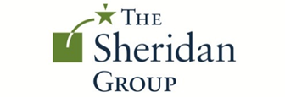

Advocacy Campaign:
Countering Boko Haram Through Health and Education Initiatives
Micaela Annis
December 11, 2017

Table of Contents

Background/Objectives…………………………………………………………………………….2-3
Key Findings…………………………………………………………………………………………...4
Policy Brief……………………………………………………………………………………………..5
Potential Partner(s) 7
Target List: Senate and House 8
Sources/ Further Readings 9

Background + Objectives

Background
Founded in 2002, when Mohammad Yusuf opened a religious complex with an Islamic school in Maiduguri, Nigeria, the Islamic extremist group Boko Haram has become increasingly more violent and pervasive over the last fifteen years. The phrase, Boko Haram roughly translates into “Western-education is forbidden,” a philosophy the group supports through violence and extremism in Nigeria, and surrounding Western African countries. Promoting a Salafist-jihadist brand of Islam, the group only began seeking to overthrow the Nigerian government in 2009 due to changes in leadership and a violent clash with Nigerian law enforcement. Previously, the group only sought to withdraw from Nigeria. Under the new leadership of Abubakar Shekau, Boko Haram has become more radical and focused on achieving an Islamic state in Nigeria through violence and extortion. In 2010, Boko Haram was weakened by Nigerian officials who killed over 700 fighters in a battle. But the group went underground, regrouped and became stronger and more pervasive than it was in the earlier 2000’s.
With Shekau’s leadership and increased cooperation with Al Qaeda, Boko Haram attacks have become more lethal, frequent and sophisticated. In 2011, in protest of the election of South Nigerian Christian, Goodluck Jonathan, Boko Haram carried out a series of bombings targeting Jonathan’s presidential inauguration. The group continued to escalate violence throughout 2011, with a following attack by suicide bomber on United Nations headquarters in Abuja. The attack killed 23 and wounded 87. That year, President Jonathan declared a state of emergency in Yobe, Borno, Plateau and Niger. Boko Haram attacks have continued and have only increasingly became a bigger threat the daily life of Nigerians.
One of the most notable Boko Haram attacks is the 2014 kidnapping of over 300 secular school girls in Chibook. The girls ranged from age sixteen to eighteen. Around fifty girls escaped almost immediately, but the majority remain still missing. Boko Haram claimed that the abducted girls have converted to Islam and are now married to members. This attack gained international attention, including a popular hashtag used on social media sites, #BringBackOurGirls. Despite this noterity, the Nigerian government has been unsuccessful in recusing the majority of the kidnapping victims. Since the 2014 kidnapping, Boko Haram has continued to target women, children, schools and rural villages. Attacks have included suicide bombings in mosques, raids of refugee camps, raping and pillaging villages, and more abductions. Although there are discrepancies on the size of Boko Haram, most estimates put the group at 15000-20000 members. Regardless of membership, Boko Haram is responsible for over 10000 civilian deaths in Nigeria and surrounding regions, in addition to displacing over 1.5 million people. The guerilla group was also listed as the world’s most deadly terrorist group by the Institute for Economics and Peace in 2015.

Objectives
Based on Boko Haram’s prevalence in Western Africa and ineffectiveness of current Nigerian, U.S. and intergovernmental policies to counter the extremist group, the U.S. must reconsider strategy and goals for countering violent extremism in Nigeria.
Through new policies and action, the U.S, in collaboration with the Nigerian government and the United Nations, should seek to:
- Increase primary and secondary school enrollment rates in Nigeria. Currently both boys and girls face dismal rates of enrollment- with boys at 61% and girls at 55% enrollment. The U.S. should seek to have all children (ages 5-16) enrolled in schools at a 70% rate by 2023.
- Expand comprehensive prenatal and maternal health care in Nigeria, and seek to have these services available to all women by 2023.
- Offer regional jobs and skills training for women based on the areas with the largest need.

Why This? Expected Benefits
In Nigeria, in Iraq and Afghanistan and in other countries facing intense conflict and violent extremism, U.S. military aid has been ultimately ineffective in demobilizing terrorist groups. According to the United States Institute for Peace:
- Despite persistent counterterrorism (CT) operations, globally the threat of violent extremism (VE) is higher today than in August 2001.
- Though it has effective CT capability, the U.S. military lacks a comprehensive strategy for countering and eliminating the drivers of VE.
- Because unstable, fragile states provide gateways for violent extremist organizations to establish a territorial base and recruit, the Department of Defense should adopt a comprehensive counter-VE strategy that complements reactive CT operations with preventative, proactive stability operations.
- Stability operations as part of CVE strategy should be grounded in an understanding of local context that identifies and addresses the grievances that lead to VE. Such operations require close partnering with civil society organizations.
Essentially, current DOD CVE initiatives in Afghanistan and Iraq have been ineffective. Althought there are not as many “boots on the ground” in Nigeria, or any part of the Sahel region, U.S troops would likely face the same failures in countering Boko Haram as they have with ISIS or Al Quaeda. The U.S. military stragety to fight terrorism with reactionary violent inititives is ineffective, costly, and lacks culture sensitivity or collaboration with local leaders and citizens. As a global leader, it is our responsibility to intervene in Nigeria. But as a global peacekeeper it is our responsibility to do so responsibly.
The above goals acknowledge how Boko Haram takes and maintains control- often through targeting villages with few resources and little ability to be autonomous. These goals work towards strengthening villages and Nigerian people so they are less sucesptible to Boko Haram attacks when and if they occur. Instead of working retroactively, the U.S. can help Nigerians build stronger and more prepared communities. Through better health and education, Nigerians will not only be better prepared to counter Boko Haram attacks, but more successful in achieving longterm development goals which not only address poverty, but also are sustainable in fighting violent extremism.

Recommended Strategy
In order to secure support for these goals, The Sheridan Group should work towards building a coalition of organizations, corporate partners, government agencies and elected officials who are willing to reconsider U.S. military straegty in Nigeria and focus on aid and dcvelopment in order to counter Boko Haram. This multi-faceted coalition should work towards developing sound policy and funding to achieve these goals in Nigeria.

Key Findings

Women in Nigeria Source: Women for Women International
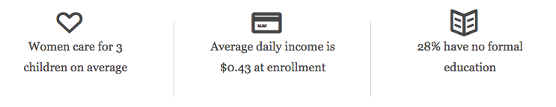

Boko Haram Violence Proliferation Source: The Washington Post

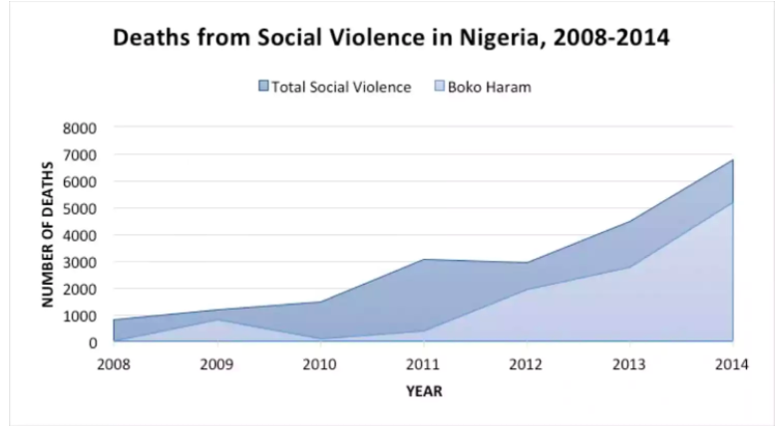

Boko Haram Attacks by State source: Council on Foreign Relations
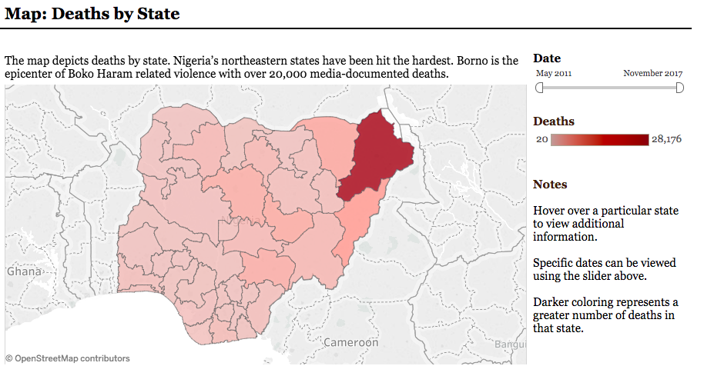

Policy Brief

Ask: Under the Department of Defense (DOD) budget, the US should focus counter violence strategy in Nigeria on health and education initiatives. Through collaboration between the State Department, Agency for International Development (USAID) and the DOD, the US should seek to increase primary and secondary school enrollment rates in Nigeria, expand comprehensive prenatal and maternal health care in Nigeria, and offer regional jobs and skills training for women based on the areas with the largest need. The US should work in tandem with the United Nations and Nigeria government to accomplish these goals by 2023.

FY 2018 Proposed Report Language

The United States Senate Committee on Foreign Affairs sees preventive CVE measures as the most effective and financially responsible way to counter Boko Haram insurgency in Nigeria. In light of the group’s tactics, which include targeting underdeveloped communities and victimizing women, the Defense Security Cooperation Agency, under the U.S. Department of Defense must work in tandem with other U.S. agencies (i.e. the State Department, and USAID), as well as the United Nations, the Nigerian government and private and non-profit partners to better women’s health, create more opportunities for women, and increase children’s access to education. Specifically, the Committee has set the following goals in reference to countering Boko Haram in Nigeria.
First, in light of dismal school enrollment rates for both boys and girls in Nigeria, the Committee has set a goal to have all children (between the ages 5-16) enrolled in school at a rate of 70% by 2023. This is a 9% increase in enrollment for boys and a 15% increase in enrollment for girls. The Committee plans increase school enrollment rates through a strong partnership with Nigerian government officials. The U.S. agencies will assist in ensuring access to facilities, training teachers, providing materials. Local Nigerian governments will remain autonomous in planning curriclim and managing day-to-day operations. By providing resourses, the U.S. will become a partner in increasing education rates, but in order to be effective most decisions must be left to Nigerian local-leaders, with aid depending on the inclusion of girls in schools. These schools must be secular, with the goal of educating Muslims and Christians in an inclusive and coexistent environment, considering much of Boko Haram’s violence has been based on historic tensions between Christians and Muslims.
Furthermore, the U.S. will work with the U.N. and Nigerian officials to maintain these schools. Outside of school hours these sites will be used for job and skills training for women. Nigerian women will have the ability to take classes on subjects that will be decided on a need based basis at each specific village. Through need-based training, women who have not had the opportunity will have the chance to build businesses, expand their job skills and become more financially and socially autonomous. Through this autonomy women are less suceptable to Boko Haram attacks or becoming dependent on Boko Haram for resources.
Lastly, the Committee is also prioritizing women and infant health to counter the proliferation of Boko Haram. The U.S. should provide aid in funds and resources to already exisiting factilities dependent on these facilities providing access to preventive reproductive health care, prenatal check-ups and post-natal health care. The Committee sees improving upon women’s health as a necessary tactic for countering Boko Haram violence. The U.S. should partner with already exisiting systems to provide the best comprehensive health care for women in underdeveloped areas and living in poverty

Potential Partners

U.S. Government Agencies
- Department of Defense: Defense Security Cooperation Agency
- United States Agency for International Development
- United States State Department
International Partners
- Nigerian Government
  - Focus on State and Local leaders
  - United Nations Women
Private and Non-Profit Partners
- NURU International
- Women for Women International
- International Rescue Committee

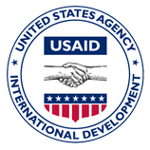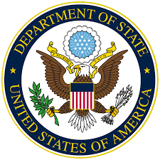

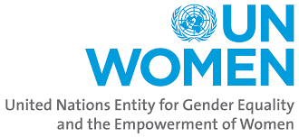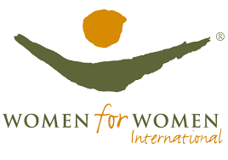
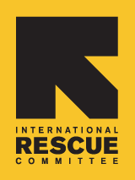

Target List: Senate and Congress

Member Name | Party | State | Committee
Corker | R | TN | SFRC (Chairman)
Kaine | D | VA | Armed Services  SFRC: Western Hem., Transnational Crime, Civilian Security, Democracy, Human Rights and Global Women's Issues
Coons | D | DE | Approps: SFOPS  SFRC: Africa and Global Health Policy
Murphy | D | CT | Approps: SFOPS  SFRC
Graham | R | SC | Approps: Defense  Approps: SFOPS (Chairman)  Armed Services: Emerging Threats and Capabilities
Leahy | D | VT | Approps (Ranking)  Approps: SFOPS (Ranking)
Reed | D | RI | Approps: Defense  Armed Services (Ranking)
Collins | R | ME | Approps: Defense
Flake | R | AZ | SFRC: Africa and Global Health Policy (Chairman)  SFRC: Western Hem., Transnational Crime, Civilian Security, Democracy, Human Rights and Global Women's Issues
Rubio | R | FL | SFRC: Africa and Global Health Policy  SFRC: Western Hem., Transnational Crime, Civilian Security, Democracy, Human Rights and Global Women's Issues (Chair)
Cardin | D | MD | SFRC (Ranking)  SFRC: Africa and Global Health Policy
Nelson | D | FL | Armed Services: Emerging Threats and Capabilities (Ranking)
Markey | D | MA | Approps: SFOPS  SFRC: Africa and Global Health Policy (Ranking)  SFRC: Western Hem., Transnational Crime, Civilian Security, Democracy, Human Rights and Global Women's Issues
Gardner | R | CO | SFRC: Western Hem., Transnational Crime, Civilian Security, Democracy, Human Rights and Global Women's Issues
Isakson | R | GA | SFRC: Africa and Global Health Policy  SFRC: Western Hem., Transnational Crime, Civilian Security, Democracy, Human Rights and Global Women's Issues
Udall | D | NM | SFRC: Africa and Global Health Policy  SFRC: Western Hem., Transnational Crime, Civilian Security, Democracy, Human Rights and Global Women's Issues
Barrasso | R | WY | SFRC: Africa and Global Health Policy

NOTE: This target list has been adapted from the Nuru 2017 Target List, focusing primarily on champions of Nuru and SFRC members

One Pager

Countering Boko Haram Through Health and Education Initiatives
The Problem:

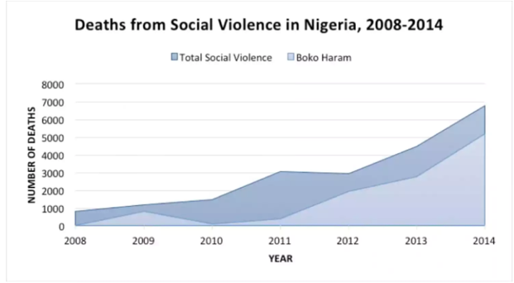

The Solution:

Sources

Boko Haram:
Stanford
http://web.stanford.edu/group/mappingmilitants/cgi-bin/groups/view/553?highlight=boko+haram
International Crisis Group
https://www.crisisgroup.org/africa/west-africa/nigeria/nigeria-women-and-boko-haram-insurgency
Al Jazeera
http://www.aljazeera.com/programmes/specialseries/2016/11/boko-haram-rise-nigeria-armed-group-161101145500150.html
Counter Extremism
https://www.counterextremism.com/threat/boko-haram
LA Times
http://www.latimes.com/world/africa/la-fg-nigeria-boko-haram-20151222-story.html
The Washington Post
https://www.washingtonpost.com/news/monkey-cage/wp/2014/10/06/the-boko-haram-insurgency-by-the-numbers/?utm_term=.b4659a6bb034

Women and Development:
BBC
http://www.bbc.com/news/blogs-trending-33239356
Women for Women International
http://www.womenforwomen.org/what-we-do/countries/nigeria

US Military Strategy:
US Council on Foreign Relations
https://www.cfr.org/sites/default/files/pdf/2014/11/Nigeria_CSR70.pdf
The New Yorker
https://www.newyorker.com/news/daily-comment/the-enduring-american-military-mission-in-africa

USIP
https://www.usip.org/publications/2017/06/militarys-role-countering-violent-extremism
DOD Report
https://www.acq.osd.mil/dsb/reports/2010s/DSB-CVE-FinalReport-April172015.pdf

