ITALIAN ARTIFACT RESTITUTION: WHO OWNS HISTORY?

T. Albert Fujii
Professor Laura Field, Ph.D.
American University, School of International Service
SISU-306: International Relations Research
9 May 2017
Abstract

After countless international laws and bilateral agreements, Italy still has an exceptionally low rate of restitution; many of Italy’s artifacts are still bought and sold throughout the international artifact black market. This paper addresses this issue of Italian artifact restitution and takes up the question: How do international actors such as museums and government task forces construct meanings about ownership? Current scholars approach restitution using economic theory to address postcolonial economic structures, social theory to analyze imperial symbolism within museums, and legal theory to consider the role of bilateral agreements and international legal norms. However, there is an absence of research into the way that international restitution taskforces and museums frame ownership. To address this gap, I evaluated discourses from Italian and U.S. news sources, official webpages of museums and taskforces, and Twitter communiqués between museums and taskforces. This discourse analysis reveals that U.S. and Italian taskforces operate with similar meanings of ownership, while U.S. and Italian museums do not. Furthermore, I argue that there is very little interactive meaning making about ownership between museums and taskforces: museums fundamentally understand ownership differently than taskforces. This disconnect speaks to the larger debate within the antiquity community about who owns history.

Keywords: UNESCO; artifact restitution; provenance; ownership; Italian-U.S. relations.
Definitions: provenance: the history of ownership of an artifact; restitution and repatriation: the return of stolen artifacts or cultural objects.

Introduction

The use of artifacts as symbols of imperial dominance began with the first civilizations. Take the Roman Empire as a prime example. In 49 B.C.E., Julius Caesar conquered Egypt after defusing a fierce civil war between Cleopatra and her brother Ptolemy. To assert power, Caesar stole countless artifacts, such as magnificent limestone obelisks, and displayed them in Rome as conquests of war. This relationship between symbolic military conquests and ownership continues today. Look no further than a similar obelisk currently at the heart of the United States’ capitol: The Washington Monument.

While it may seem innocuous, the power evoked by the monument asserts that the U.S. owns the legacy of the obelisk; the U.S. parallels itself with ancient empires as a symbol of imperial power. This form of identity politics trickles down into museums as well. For example, the display of Indian artifacts in private British collections confirms the post-colonial legacy of ownership. Furthermore, when history is represented by tangible artifacts, the historical record can not only be bought and owned, it can also be stolen. In fact, the display of stolen artifacts sterilizes ethics from ownership and adds a deeper amoral dimension to lasting colonial traces. Nevertheless, some countries, such as Italy, are taking a stand against the illicit commercialization of artifacts by redefining ownership in the practice of artifact restitution.
The first breakthrough for artifact restitution efforts was the 1970 United Nations Educational, Scientific and Cultural Organization (UNESCO) Convention where 120 countries came together to grapple with the puzzle: who owns history? The agreement laid out a shared obligation to “adopt protection measures, control movement of cultural property, and return stolen cultural property.” Even though every country in attendance signed, the agreement’s success is below the anticipated level. According to UNESCO, Italy had just four successful restitution cases, even after implementing domestic policy and bilateral agreements charged with fostering collaboration between restitution taskforces and museums. Due to this low rate of restitution, Italy adopted alternative “grey solutions” such as museum loan programs. These programs are breakthroughs in the way that nations approach restitution because they circumvent traditional legal pathways. However, they also come with disadvantages. They are obstructed by museums because each museum treats ownership uniquely. The programs also lack enforcement mechanisms, such as international taskforces, because they operate outside the parameters of legal pathways for restitution. The purpose of this paper is to explain why museums treat ownership differently than international taskforces. As such, the central question of this paper is: With respect to Italian artifact restitution, how do international actors such as museums and government task forces construct meanings about ownership?

Existing Literature
This paper builds on the existing scholarly foundation in three distinct ways. First, economic theorists argue that post-colonial economic lines create fluctuating illicit markets that are split into geographic regions, often determined by levels of development. Second, social theorists explore the role of identity politics in ownership of cultural property such as artifacts. Finally, legal theorists grapple with the 1970 UNESCO Convention, domestic patrimony laws, and legal enforcement mechanisms.
Economic theory is necessary to understand artifact restitution because illicit trade networks are measurable economic markets. The existing body of literature identifies that these markets are estimated at two to six billion dollars. However, these market values are not always reliable. For instance, the size of these illicit markets fluctuates due to external factors such as war. Also, because these trade networks are illegal, the true value of income is not reported which leads to substantial quantitative issues for governmental reporting agencies. These drawbacks are why many scholars use discourse analysis to bypass quantitative issues.
Economic theory also sheds light on post-colonial influences. For instance, national borders are often contested because colonial nations wielded the power over the division of land and resources. As such, postcolonial economic theorists split illicit markets into two categories: market and source nations, which often highlight development inequality. Market nations are where artifacts are purchased while source nations are where artifacts are stolen. Economists use this dichotomy to identify where economic solutions should be applied. One group argues that economic solutions are necessary in source nations because artifact scavenging provides jobs for local villagers that are often impoverished due to war. Other literature identifies the market nations as the space for economic solutions such as sanctions, tariffs, and tax penalties. Specifically, some scholars research economic sanctions and their ability to curb cross-border networks that are run by robbers as well as archaeologists. Other market nation solutions are tax penalties for museums that buy artifacts with illegal provenance histories.
In terms of social theory, many scholars address the role of colonialism on the social construction of ownership. One such example throughout the literature is the concept of war and “war booty.” The French, after their colonial annexation of Cambodia, now display many Cambodian antiquities in their museums. Such “stolen” artifacts are displayed in “encyclopedic museums” that solidify social power politics; when traditionally colonial powers display artifacts from all over the developing world void of historical or cultural context, they fetishize and diminish the “elsewhere.” These paternalistic museums argue that cultures from “elsewhere” are unable to financially care for their own artifacts. They argue that developing nations, often war stricken, are unable to ensure the safety of artifacts. As a result, the artifacts must be “preserved” or “saved” in encyclopedic museums. Other social scholars analyze the effects of these colonial conquests on local identity politics. These scholars assert that autonomous artifact ownership contributes to a culture’s identity and pride. As such, the theft of these artifacts diminishes local identity.
Social theorists disagree about how to resolve these colonial and identity issues. They are generally divided into two groups: internationalists and nationalists. International theorists argue that artifacts should be shared globally and should not be returned to one single country. The alternative argument is that artifacts are socially essential to national identity. For example, Saddam Hussein invested in archaeological efforts to re-create the “New Babylon” to create one national identity founded in artifacts.
Most economic and social theorists acknowledge that the foundation for restitution rests in legal theory. These legal theories include international legal apparatuses implemented after the 1970 UNESCO Convention. They also address the problems that ratification of domestic patrimony laws face due to a lack of enforcement mechanisms. Specifically addressing Italian restitution, legal theorists analyze “grey solutions” that bypass domestic and legal apparatuses such as bilateral agreements and museum loan programs.
In terms of international law, most legal scholars identify UNESCO as the primary legal institution to call for decisive channels for restitution. The 1970 UNESCO Convention, an agreement between 120 countries, sets forth three fundamental policies that countries must ratify and agree to: protect artifacts domestically, control movement of artifacts, and return artifacts. Scholars disagree on the effectiveness of this convention. Some legal scholars believe that the convention is responsible for increased artifact restitution rates. Others are skeptical because of issues with legal diversity (different countries hold private museums to different legal standards). Legal theorists also identify issues with jurisdiction. For example, Italy must sue for restitution in the courts of the country in control of the artifact which means that their domestic legal protections do not apply. Other theorists think that international law is not an effective solution because it lacks intentional recognition and authority due to the fact that there are no enforcement mechanisms in place in the 1970 UNESCO Convention.
Like international law, some legal theorists argue that domestic law is not effective because it does not contain monetary value to artifacts or enforcement mechanisms such as criminal liability. In addition, Simon Mackenzie argues that enforcement mechanisms are not effective because patrimony laws are interpreted socially instead of legally. In terms of acquisitions, for instance, social interpretation of law fostered widespread acceptance that a lack of provenance does not detract from value. Such social interpretation is also influenced by the language used to construct meanings about ownership. For example, wording in patrimony laws shows a wide diversity in defining “cultural object” which leads to ineffective domestic law.
Therefore, social theorists identify the symbolism behind restitution and the identity politics associated with the use of cultural context in framing ownership. In addition, economic scholars approach restitution using the impact of postcolonial economic structures. These two bodies of literature, however, do not address power relationships that are not colonial, such as the U.S. and Italy; both the U.S. and Italy do not have extensive colonial histories like England and France. Finally, legal theory identifies how provenance information can reveal underlying interests of museums and taskforces. Legal and economic theory also suggests market nations are invested in provenance transparency to prove legal standing for restitution. This paper offers a critique of these legal theories and identifies that current legal assumptions do not fully account for museums’ investment in restitution.

Methodology
This project is a discourse analysis because the answer to the question of shared meanings of ownership between taskforces and museums is not rooted in the text of international or domestic law. Instead, literature points to the implementation and practice of law as the reason for differing viewpoints about ownership. The appropriate method to analyze this dilemma is discourse analysis because it can uncover the reason for differing social practices. Looking at how such meanings are constructed helps us understand the role of market accountability and responsibility, national and post-colonial identity, and the vulnerability of legal frameworks has on the framing of ownership. Furthermore, discourse analysis circumscribes the quantitative dilemma that museums are not required to publish data about their acquisitions.
I chose two actors for this discourse analysis: museums and international taskforces. This decision is based on the 2006 bilateral agreement between the United States and Italy. In this legal document, museums and taskforces are charged with shared responsibility to cooperate on restitution. However, even after this agreement, restitution rates did not go up. Therefore, understanding differences in fundamental understandings of ownership between these two actors could provide insight into why the implementation and practice of restitution is still so low.
In terms of museum discourses, I used a combination of website data and Twitter posts. For Italian museums, I collected discourses from the websites of the Musei Capitolini, the Civico Museo Archeologico, and the Museo Nazionale Romano. I also considered discourses of U.S. museums including the Toledo Museum of Art, the Seattle Art Museum, the Metropolitan Museum of Art, and the Museum of Fine Arts in Boston. I chose these specific museums because each had designated exhibits for Roman artifacts. For each of these web site sources, I gathered information from four to five of the individual pages that depicted a specific Roman artifact. In addition to these pages, I analyzed official Tweets from the Gallerie Uffizi and the Metropolitan Museum of Art, both of which are museums that have extensive Roman artifacts in their collections. For concision, I chose Tweets that had similar hashtags and content that addressed ownership. For example, I analyzed Tweets that used terms such as “#stolen” or “#repatriated.”
For international taskforces, I analyzed discourses by U.S. and Italian restitution taskforces, including the Italian Carabinieri, the U.S. State Department, the U.S. Federal Bureau of Investigation, and U.S. Homeland Security. I chose these specific agencies because their websites include information about artifact restitution. In addition, their Twitter pages were also active with posts about restitution efforts. In choosing which Tweets to analyze, I used similar parameters to the museums Tweets. The Tweets needed to contain words and phrases related to ownership and they needed to be focused on the topic of either restitution or Italian artifacts.
I analyzed the language of these diverse discourses using four methodological tools: temporal indicators, visual context, transparency of provenance information, as well as key words and phrases concerning ownership. Temporal indicators, also known as temporal proximity, are words and phrases that identify how an actor understands time in relation to a social practice. These temporal markers vary from explicit increments of time to vague statements such as “recently.” In terms of this research, I looked for textual references to the relationship between contemporary Italy and Ancient Rome. Indication of the nexus between these two temporal contexts gives insight into the level of responsibility that the historical provenance has on an institution’s notion of ownership.
Visual discourse analysis is another important tool since images give insight into socially constructed value systems. I split visual analysis into three levels. The first level is semiotic visual analysis which identifies the symbolism behind the social context related to the production of meanings using visuals. The second level is the symbolic representations of the images themselves. This includes the position of the objects within the photograph, but most importantly, the context the objects are placed in. The context, or lack thereof, gives insight into the value system of an organization. The third level is interaction with the audience since the use of visuals inherently involves others. This interaction reveals who the entity believes the audience is and what values they want to communicate to that audience. As such, all three levels combine into an understanding of the values system being employed in the construction of meanings within the visual manifestation.
The final form of analysis is the linguistic identification of common themes within discourses, including key phrases and words linked to meanings about ownership. For example, key words such as “stolen” and “returned” identify shared understanding that an artifact has an illicit provenance record, which is the first step to restitution. In contrast, words like “found” or “discovered” bypass legal obligations of ownership and instead allow the archaeologist or smuggler to take ownership. Specifically on Twitter, these examples often manifest themselves as “hashtags” which are linguistic links attached to specific words. Furthermore, key terms on Twitter can also include “handles” which are direct links to other Twitter users, identified by an “@” at the beginning of a name.
After analyzing the individual discourses, the next level of analysis is the intertextuality of the discourses. The primary forum for such shared understandings about ownership was Twitter because museums and taskforces could directly interact. Consequently, the use of identical hashtags as well as a user’s ability to “tag” another user’s “handle” indicated a mutual meaning-making process. Furthermore, “retweeting” certain posts by other users also indicate adoptive understandings of content. Apart from Twitter, shared press conferences were also an important part of addressing intertextuality, specifically the shared language and symbols represented by both Italy and the United States.
Due to the nature of my project and its reliance on Twitter, it is important to address a few of its limitations. First, the concept of cultural competence is necessary for my transparency as a researcher. I needed to rely on Bing’s translating algorithm for Tweets in Italian since I am not fluent in Italian (the use of which is noted in the citations of translated Tweets). While there are known setbacks to algorithms since they often miss crucial language nuances, I did not conduct micro-level analysis of translated texts such as analysis of word choice or verb tense. Therefore, my analysis has a lower level of risk misinterpretation. Another facet of cultural competence is the fact that I work at the Seattle Art Museum which gives me familiarity of cultural nuances within museums, specifically concerning provenance research for ancient artifacts and the way museums visually present artifacts.
Since the fundamental assumption of interpretivist research is that a researcher cannot separate from the research context, I must also address reflexivity and trustworthiness. Reflexivity is defined as “the systematic consideration of a researcher’s characteristics.” While characteristics often include identity, race, gender, and culture, the relevant characteristic regarding this research is my culture. I am a United States citizen which could impact the way I view the United States; as a domestic citizen, I tend to be critical of the U.S. role in the world. Furthermore, it is important to note that I am also a past employee of the Seattle Art Museum. My experience with this museum shapes the way I note provenance since, as an employee of a U.S. museum, I was taught to understand provenance in a U.S. manner which could inhibit my ability to comprehend Italy’s understanding of provenance. Also, because the Seattle Art Museum is one of my sources, I may include context beyond the text itself since I am familiar with the museum’s process of recording provenance.
For trustworthiness, I took concrete steps to ensure that my methods were transparent and that the data analyzed was reputable and accurate in capturing the social practices between the two actors. For example, I used a wide range of museum webpages to maximize the data’s ability to be representative. I carried this method into the taskforce discourses as well, resulting in a transparent and trustworthy sample of texts.

Analysis
The foregoing methods provided vital insight into the way museums and taskforces understand ownership. My analysis supports multiple conclusions concerning understandings about temporal indicators, provenance information, and use of visual context. However, due to the extent of these findings, I will discuss three of the most important conclusions: the extent of provenance information on museum websites, the use of visual context by museums, and the shared understanding about ownership and cooperation of the international taskforces. I explore discourses by U.S. and Italian restitution taskforces and then turn to considering the findings related to museum discourses.
First, discourses of U.S. and Italian artifact restitution taskforces identified a high level of shared understanding of illicit provenance, resulting in a shared call for international cooperation. Both discourses indicated a shared meaning making about the intersection between illicit provenance and ownership. Take the following examples:
Heritage at State‏ (@HeritageAtState):

“In case you missed it @FBI returned stolen Roman statue to @MiBACT @_Carabinieri_”

Remarks at FBI press conference by commander of the Carabinieri:

“We are very happy when something that belongs to the Italian patrimony can be brought back to our country, but it is not a matter of Italy. It’s a matter of every country. When there is something that is stolen from a country, to come back to their own country, I think it’s very important, because this is a symbol of the community, a symbol of the nation.”

In the first Tweet, the U.S. State Department uses the word “stolen” which clearly communicates an understanding of illicit provenance. The Tweet also creates a temporal link by drawing the nexus between ancient Rome and contemporary Italy, identified by the tag of “@MiBACT” which is the Italian ministry of Culture and Tourism. Furthermore, the inclusion of both the FBI and Carabinieri is a prime example of intertextuality, or shared meaning making. This shared meaning making about illicit ownership is further illustrated by the remarks by General Fabrizio Parrulli, the commander of the Carabinieri, who reaffirms illicit provenance and the symbolic value of the FBI’s repatriation ceremony. This interactive meaning making sparked several “retweets” by the Carabinieri, the FBI, as well as Italian print media which all repeatedly used words (and hashtags) such as “stolen,” phrases like “repatriated to Italy,” as well as identical visual contextualization (the sources used the same picture of the repatriated statue). As such, using the Peplophoros restitution as one example, U.S. and Italian taskforces understand ownership similarly by acknowledging illicit provenance.
This shared understanding results in meaningful action, as both U.S. and Italian taskforces engage each other in calling for international cooperation. They share press conferences about restitution cases, coining the term “repatriation ceremonies.” Furthermore, in Tweets such as the highlighted example above, the two sets of taskforces consistently tag each other’s respective Twitter “handles” which signifies a level of cooperation and transparency between the two. In each example, the nexus for this cooperation is the United States Embassy in Italy. Notably absent from this cooperation are museums; Italian and U.S. museums are not tagged, referenced, or engaged.

Second, there is no shared understanding of ownership between museums. I found there are stark differences in the extent of provenance transparency, illustrated above in Diagram 2. Most Italian museums’ websites published little to no provenance information. Furthermore, none of the Italian museums included words or phrases to link historic provenance and contemporary ownership. For instance, the Museo Nazionale Romano, in its explanation of the Sarcophagus of Portonaccio, uses the term “Roman” throughout, however, it does not use contemporary markers like “Italy”; there is a separation between ancient provenance and contemporary identity. U.S. museums, in contrast, included detailed provenance records. While every U.S. example included object catalogue numbers and ownership data, some U.S. museums also cited references, bibliographical information, publication records, and exhibition history, all of which demonstrate disposition towards accountability of provenance. As such, there is a clear divide between provenance transparency between Italian and U.S. museums, a counterintuitive paradox I will address below.
Third, analysis indicated that the websites of both U.S. and Italian museums excluded visual context by including photographs that were taken with neutral backgrounds. However, on Twitter, Italian used visual context in photographs to link ancient Rome and modern Italy. Specifically, Italian museums Tweeted about Italian artifacts using temporal contextual elements. For example, some included photographs of artifacts displayed in historic settings such as Roman villas, giving insight that these museums valued the relationship between time and ownership. Conversely, the U.S. museums Tweeted pictures without this context; they continued to use plain backdrops that disengaged the artifacts from visual and historic context. Therefore, Italian museums created a temporal nexus between ancient Rome and contemporary Italy while U.S. museums isolated the ancient historical period.
The fact that U.S. and Italian taskforces share understandings of ownership offer a critique to current legal theory that suggests legal institutions are ineffective at crafting shared meaning-making. It also serves as a counter to post-colonial economic and social theory. The two findings related to museums and their acknowledgement of provenance transparency and temporal context run counter to logical intuition; one would expect that Italian museums publish more provenance because they are invested in the restitution for their own artifacts. However, current legal assumptions suggest that Italian museums are not invested in restitution. As such, when these findings are applied to legal, economic, and social theory, they highlight a striking paradox.
The first finding that international taskforces’ share understanding about ownership and they have a collective call for international cooperation adds new dimensions to existing legal and post-colonial theory. Legal theorists widely claim that international and domestic law, including bilateral agreements, are not effective at fostering meaningful cooperation. However, this paper finds that taskforces take pride in their adherence to both domestic and international law. Instead, it is museums that are inhibiting restitution, not international taskforces. To supplement this dilemma, legal theory should continue to support the collaboration between taskforces.
The shared understanding between intentional taskforces also has implications on post-colonial economic and social theory which argues that market nations in positions of power harvest artifacts to reduce a source nation’s autonomy over its cultural identity. Because the relationship between the U.S. and Italy is not colonial, and their taskforces cooperate, this paper supports the conclusion that inhibition to restitution by national legal institutions like taskforces is less likely to occur if the involved parties do not share a colonial past. Therefore, policy must focus on fostering cooperation, through international law and bilateral agreements like the U.S.-Italian agreement, between countries that do not share colonial pasts to set a precedent of successful cooperation.
The second and third findings of this analysis identify that museums fundamentally understand ownership differently than taskforces. First, museums understand the role of time differently, indicated by the inclusion or absence of a contextual nexus between contemporary Italy and ancient Rome. This dynamic applies post-colonial theory to the case of the U.S. and Italy. For example, Davis identifies that the use of temporal indicators, such as visual context, reveals the deeper interests of the parties involved; is restitution truly in the best interest of the dominant party? Therefore, the fact that U.S. museums sterilize contemporary Italy from their construction of ownership suggests that U.S. museums are not invested in restitution. This draws an important parallel to colonial powers’ circumscription of responsibility by only considering the historical record of artifacts. As such, policy must consider current international power dynamics and the role that economic development has on restitution because global inequality does not just effect post-colonial nations.
Next, Italian and U.S. museums understand the role of transparent provenance differently. Legal theory provides insight into why this difference may exist: museums or not legally required to be transparent with the provenance of acquisitions. This must change. Policy must require that museums publish their acquisition data. Policy should also apply post-colonial economic supplements to countries without colonial paths. For example, Italy should impose tax penalties for museums that buy artifacts with illegal provenance histories, a strategy that many source nations already require
The difference of provenance transparency is pyridoxal because legal literature suggests that museums with illicit or suspicious artifacts do not publish provenance. This paper, however, finds that it is U.S. museums that are transparent with provenance and not Italian museums. Italian museums’ exclusion of provenance is counterintuitive because legal theorists such as Amineddoleh and Mackenzie argue that provenance is the legal tool to prove standing in legal courts. As such, it would logically be in the best interest of Italian museums to publish their provenance so that they could increase Italy’s low rate of restitution. In fact, the absence of provenance is considered acknowledgement of illicit origin. As such, Italy stands as a challenge to existing legal literature and the fundamental assumptions of restitution. This case also stands as an exemplar that the international court system is overly dependent on Western application of numerical data to ownership. Policy, therefore, must consider other indicators of ownership, such as temporal markers, so that restitution is available to a diversified group of nations and not just nations familiar with Western legal norms.
These three conclusions, along with their resulting paradox, offer deeper understanding regarding the dilemma of Italian artifact restitution. Differences in the use of visual context by museums indicate that there is a fundamental difference about the role temporal markers play on the meaning-making process that frame ownership. In fact, visual context suggests that U.S. museums are not invested in restitution. However, the fact that Italian museums excluded provenance information suggests, when current legal assumptions are applied, that Italian museums are also not invested in restitution. Finally, discourses from taskforces present hopeful levels of shared understanding of ownership and dedication to international cooperation. The exclusion of museums from this call for cooperation confirms that there is a serious difference in understanding of ownership between museums and taskforces, one that continues to hinder restitution efforts.
It is important to note that, regardless of the steps employed to ensure trustworthiness, there are possible alternate interpretations to the following findings. For instance, one could argue that museums and taskforces do not create shared meanings because there is no established interest for their interaction. Museums are not legally required to publish acquisitions and taskforces do not try to engage them. Another interpretation could explain visual context by noting that there are established norms for individual museums in terms of taking photographs; museums take photos with neutral backdrops across the world so that visitors may clearly observe the artifacts. Any lack of context could be attributed as unintentional.

Conclusion
There are numerous similarities and differences between museum discourses and restitution taskforce discourses concerning ownership, exemplified by their use of temporal indicators, provenance transparency, and visual contextualization. However, any connected meaning making between these two groups of actors is effectively nonexistent. This disconnect calls into question the effectiveness of international legal apparatuses.
The case of the U.S. and Italy lends explanation to why legal apparatuses for restitution is weak. The findings in this paper suggest that current legal assumptions regarding provenance are ineffective due to their reliance on Western legal traditions, identified the use of numerical data over cultural context. These assumptions explain that the U.S. museums’ transparency is not due to investment in restitution, but instead, an avoidance of responsibility; U.S. museums use numerical provenance data to hide behind the shield of free enterprise and, thus, defer blame to middle-men such as auction houses.
These findings also matter because they add unique insight into the general failures of the 1970 UNESCO Convention. Specifically, the case of Italian artifact restitution is distinctive in the sense that it addresses the role of non-colonial relationships on international restitution frameworks. And the findings are puzzling since the source country, Italy, has conflicting representations of ownership and its interest in restitution. In contrast, the United States is very transparent with provenance, even though it has almost no current restitution claims abroad.
Finally, the absence of museums from taskforce collaboration also critiques the effectiveness of bilateral agreements. Taskforces and museums are charged with cooperation in the U.S.-Italian bilateral agreement. Therefore, why do the two parties not cooperate (why are museums not tagged in taskforce Tweets)? On the one hand, by focusing on cooperative multilateral repatriation efforts, the taskforces fail to address domestic weaknesses in restitution law. For example, the Carabinieri do not call for policy initiative to force museums to publish provenance data. This identifies a contention between the private and public spheres since the findings in this paper suggest that public institutions are invested in restitution and public spheres are not. As such, public taskforces need to provide economic incentives for restitution, especially considering that current legal literature identifies that absence of provenance transparency does not affect the price of artifacts.
While these finding shed substantial light on the puzzle of Italian artifact restitution, there is more work to be done. Further research into this topic should include different cases such as British museum and taskforce discourses. Other indicators of ownership should also be explored. For example, further scholarship should address the paradox discussed in this paper and answer the questions: Why are museums excluded by taskforces from engaging in cooperative restitution measures? Why don’t Italian museums publish provenance data? An important method for developing answers to these questions could be the use of interviews with museum curators.

Bibliography

Amineddoleh, Leila. "The Role of Museums in the Trade of Black Market Cultural Heritage Property," Art, Antiquity & Law 18, no. 3 (October 2013), 227-254.

Balter, Michael. “University Suppresses Report on Provenance of Iraqi Antiquities,” Science
318, no. 5850 (October 2007), 554-555.

Banks, Marcus. Visual Methods in Social Research, 1. London: Sage, 2001.

Bresner, Katie. "Sharing Identity through Indingenous Tourism: Osoyoos Indian Band's Nk'Mip
Desert Cultural Centre," Anthropoligica 56, no. 1 (2014), 135-150.

Bright, David A. and Alison Ritter. “Retail Price as an Outcome Measure for the Effectiveness of Drug Law Enforcement,” International Journal of Drug Policy 21, no. 5 (September 2010), 359-363.

Civico Museo Archeologico. “Ritratto di Agrippina Minore,” Le collezioni,
<http://www.museoarcheologicomilano.it/wps/portal/poc?urile=wcm%3Apath%3ATUR_IT_ContentLibrary/minisito_museo_archeologico/lecollezioni/milanoromana/Ritratto_di_Agrippina_Minore> (Accessed: 23 March 2017).

Davis, Tess. "Supply and Demand: Exposing the Illicit Trade in Cambodian Antiquities through a Study of Sotheby’s Auction House," Crime, Law and Social Change 56, no. 2 (2011), 155-174.

Da Conceicao Pereira, Anabela. “Contrasting (Power of) Visual and Textual Discourses in Art
Studies: a Critical Perspective,” Visual Communication 15, no. 1 (2015), 33-53.

Denskus, Tobias and Daniel E. Esser. “Social Media and Global Development Rituals: A
Content Analysis of Blogs and Tweets on the 2010 MDG Summit,” Third World Quarterly 34, no. 3 (May 2013), 405-422.

Dery, Jeruen E. and Dagmar Bittner. “Time and Causation in Discourse: Temporal Proximity,
Implicit Causality, and Re-mention Biases,” Journal of Psycholinguistic Research 45, no. 4 (June 2015), 884.

Embassy of Egypt and Rome. "Agreement on the Cultural and Historical Property Between the
Government of the Arab Republic of Egypt and the Government of the Italian Republic in the Field of Protection and Repatriation of Cultural Property," Agreement. 003906-8554424. (Rome, Italy and Egypt: 6 September 2008), 9-13.

Embassy of the United States and Rome. "Agreement Between the Government of the United
States of America and the Government of the Republic of Italy Concerning the Imposition of Import Restrictions on Categories of Archaeological Material Representing the Pre-Classical, Classical, and Imperial Roman Periods of Italy," Agreement. 16-112. (Washington, DC: 19 January 2001), 1-3.

Erol, Ali Ersen. “’Please Don’t Be Turk, BE GREEK, BE ARMENIAN’ Agency and Deixis
Across Virtualized Turkish Imagined Community,” International Journal of Communication 7, (2013), 741-758.

Federal Bureau of Investigation. "Art Theft," What We Investigate, <https://www.fbi.gov/investigate/violent-crime/art-theft> (4 December 2016).

Federal Bureau of Investigation. "FBI Art Theft Program," YouTube, 18 March 2013, <https://www.youtube.com/watch?v=f4HHYXS2MUE&feature=youtu.be> (3 December 2016).

Federal Bureau of Investigation. “FBI New York Hosts Italian Carabinieri in Formal
Ceremony to Return Roman Statue Stolen 33 Years Ago,” News, <
https://www.fbi.gov/contact-us/field-offices/newyork/news/press-releases/fbi-new-york-
hosts-italian-carabinieri-in-formal-ceremony-to-return-roman-statue-stolen-33-years-
ago> (Accessed: 13 January 2017).

Keane, David and Valentina Azarov. "UNESCO, Palestine and Archaeology in Conflict," Denver Journal of International Law and Policy, (Spring 2013), 309-343.

Jewitt, Carey. "A Social Semiotic Analysis of Male Heterosexuality in Sexual Health Resources:
the Case of Images" cited in: Jewitt, Carey and Rumiko Oyama. Visual Meaning: a Social Semiotic Approach: The Handbook of Visual Analysis. Cape Town: SAGE Publications, Inc., 2012

Lisa Cole, Nicki. “Global Capitalism Organizing Knowledge of Race, Gender, and Class: the
Case of Responsible Coffee,” Race, Gender, and Class 15, no. 1 (2008), 170-187.

Mackenzie, Simon R. M. "Dig a Bit Deeper: Law, Regulation and the Illicit Antiquities Market." The British Journal of Criminology 45, no. 3 (2005), 249-268.

McGuirk, Siobhan. “’God Loves You and It Gets Better’ Ideology, Deixis, and Agency in an
Anti-Homophobic Bullying Viral Campaign,” Journal of Language and Sexuality 3, no. 2 (2014), 219-244.

The Metropolitan Museum of Art. “Bronze statue of an aristocratic boy,” < http://www.metmuseum.org/art/collection/search/248891?sortBy=Relevance&amp;ft=roman&amp;offset=0&amp;rpp=20&amp;pos=3> (Accessed: 21 March 2017).

Moore, Timothy J. “Australian Illicit Drug Market Data: Sources and Issues,” Australian Economic Review 39, no. 4 (2006), 442-452.

Musei Capitolini. "Hall of the She-wolf," The Collections: Through the Rooms, <http://en.museicapitolini.org/collezioni/percorsi_per_sale/appartamento_dei_conservatori/sala_della_lupa/lupa_capitolina> (Accessed: 22 November 2016).

The Museo Nazionale Romano. “Sarcophagus of Portonaccio,” Sculptures, <http://www.archeorm.arti.beniculturali.it/en/national-roman-museum-palazzo-massimo-alle-terme/sculptures/sarcophagus-portonaccio> (Accessed: 25 March 2017).

The Museum of Fine Art Boston. “Torso of a young god or athlete,” Art, < http://www.mfa.org/collections/object/torso-of-a-young-god-or-athlete-3> (Accessed: 20 March 2017).

Neumann, Iver B. “Discourse Analysis,” in Qualitative Methods in International Relations, ed. Audie Klotz and Deepa Prakash (Great Britain: Palgrave MacMillan, 2008), 63-64.

Onultalia. “Ancient statue stolen from #Rome,” Twitter, 8 December 2016, < https://twitter.com/Onuitalia/status/806853593806553088> (Accessed: 25 February 2017).

Patron, Raisa E. "The Looting of Iraqi Archaeological Sites: Global Implications and Support for an International Approach to Regulating the Antiquities Market," The George Washington International Law Review 40, no. 2 (September 2008), 465-496.

Povoledo, Elisabetta. “25 Looted Artifacts Return to Italy,” The New York Times, 26 May 2015.

Rhodes, Robin Francis. The Acquisition and Exhibition of Classical Antiquities: Professional, Legal, and Ethical Perspectives. Notre Dame: University of Notre Dame Press, 2007.

Roodt, Christa. "Restitution of Art and Cultural Objects and Its Limits," The Comparative and International Law Journal of Southern Africa 46, no. 3 (2013), 286-307.

Rose, Gillian. Visual Methodologies: An Introduction to the Interpretation of Visual Materials. London: Sage, 2001.

Rothfield, Lawrence. The Rape of Mesopotamia: Behind the Looting of the Iraq Museum.
Chicago: University of Chicago Press, 2009.

Shanahan, Mark and Meredith Goldstein. “Brutus arrives at the Museum of Fine Arts,” Boston Globe, 22 January 2013.

Shwartz-Shea, Peregrine and Dvora Yanow. Interpretive Research Design: Concepts and Processes, edition 1. (New York and London: Routledge, 2011), 78-114.

Smith, Denis Mack. Modern Italy: A Political History. Ann Arbor: University of Michigan Press, 1997.

Stanish, Charles. "Forging Ahead," Archaeology 62, no. 3 (May/June 2009), 18-66.

“State stolen from Rome goes back to Italy thanks to Carabinieri,” OnuItalia, 7 December 2016.

Stoll, Cameron Semmes. "The Effects of Judicial Decisions and Patrimony Laws on the Price of Italian Antiquities," International Journal of Cultural Property 19, no. 1 (February 2012), 65-96.

"UNESCO, Palestine and Archaeology in Conflict." Denver Journal of International Law and
Policy, (Spring 2013).

United Nations Educational, Scientific, and Cultural Organization. “Other Cases of Return or
Restitution of Cultural Objects,” Illicit Trafficking of Cultural Property, < http://www.unesco.org/new/en/culture/themes/illicit-trafficking-of-cultural-property/other-cases-of-return-or-restitution-of-cultural-objects/> (Accessed: 12 November 2016).

United Nations Educational, Scientific, and Cultural Organization. “Recent Examples of Successful Operations of Cultural Property Restitutions in the World,” Restitution of Cultural Property, <http://www.unesco.org/new/en/culture/themes/restitution-of-cultural-property/successful-restitutions-in-the-world/> (Accessed: 12 November 2016).

United Nations Educational, Scientific, and Cultural Organization. “Return or Restitution Cases,” Restitution of Cultural Property, <http://www.unesco.org/new/en/culture/themes/restitution-of-cultural-property/return-or-restitution-cases/> (Accessed: 12 November 2016).

United Nations Educational, Scientific and Cultural Organization. The Fight against the Illicit Trafficking of Cultural Objects: The 1970 Convention: Past and Future. Paris: UNESCO, 2011.

United States Department of State. “U.S.-Italy Cultural Property Agreement: Memorandum of
Understanding between the United States and Italy,” Bureau of Educational and Cultural Affairs, 19 January 2001, < https://eca.state.gov/cultural-heritage-center/cultural-property-protection/bilateral-agreements/italy/us-italy> (Accessed: 27 February 2017).

The United States of America and Italy. “Memorandum of Understanding: Cultural Property,” 13
January 2006.

Wood, Elisabeth Jean. “The Ethical Challenges of Field Research in Conflict Zones,” Qual
Sociol 29, (2006), 373-386.

Wood, Paul. "Display, Restitution and World Art History: The Case of the ‘Benin Bronzes’," Visual Culture in Britain 13, no. 1 (2012): 115-137.

Yates, Donna. “Church Theft, Insecurity, and Community Justice: The Reality of Source-End Regulation of the Market for Illicit Bolivian Cultural Objects,” European Journal on Criminal Policy and Research 20, no. 20 (December 2014), 445-457.

Zengin, Bugra and Isil Gunseli Kacar. “Turkish EFL Academicians’ Problems Concerning
Translation Activities and Practices, Attitudes Towards the Use of Online and Printed Translation Tools, And Suggestions for Quality Translation Practice,” The Turkish Online Journal of Educational Technology 10, no. 2 (April 2011), 274.

Appendix 1, Selected

1.1 | 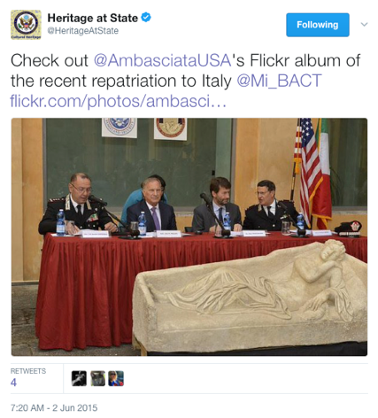
1.2 | 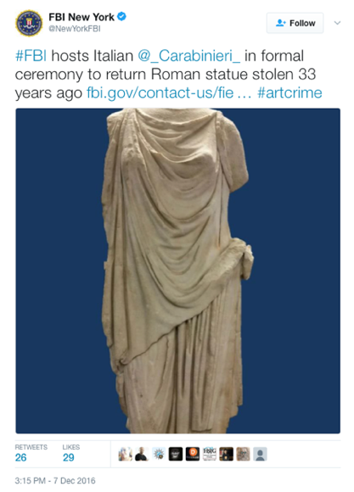
1.3 | 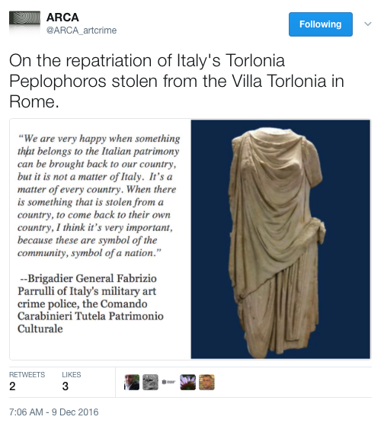
1.4 | 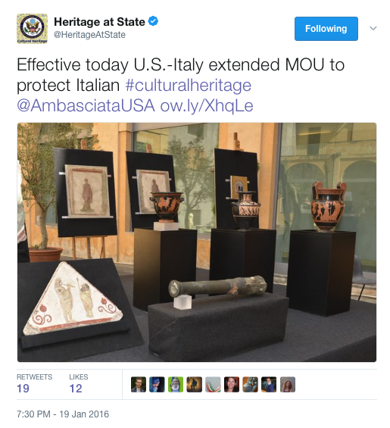
1.5 | 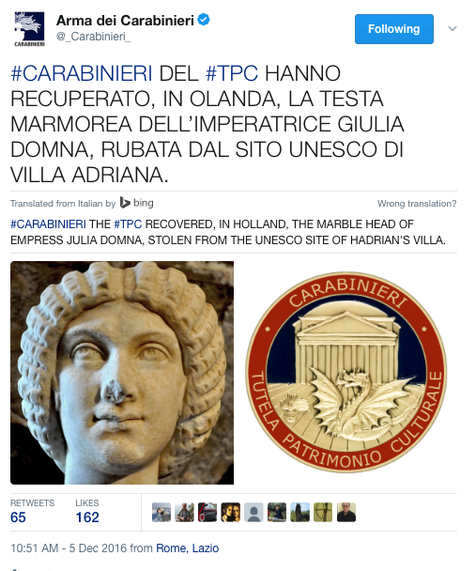
1.6 | 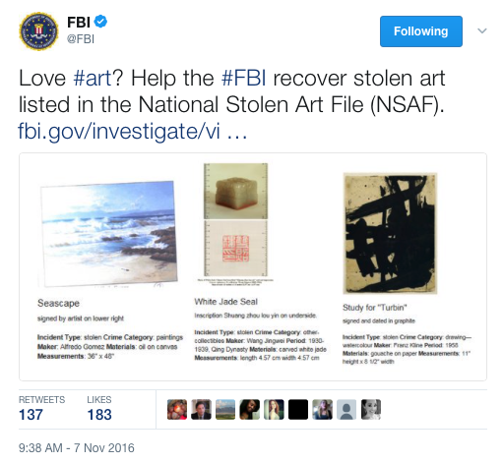
1.7 | 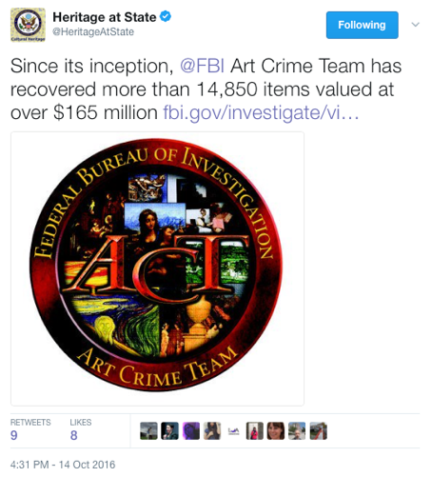
1.8 | 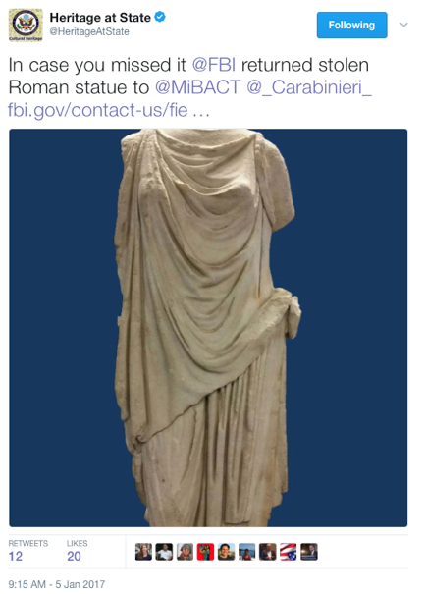
1.9 | 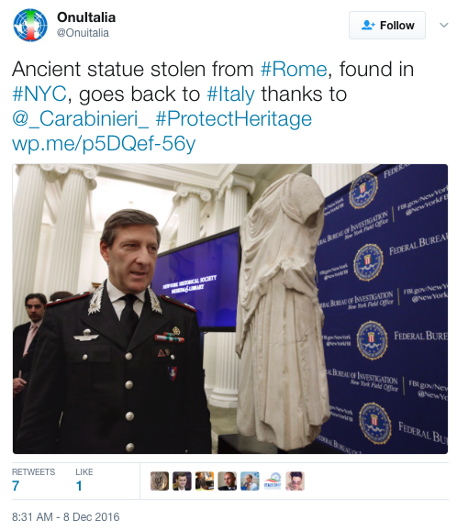
1.10 | 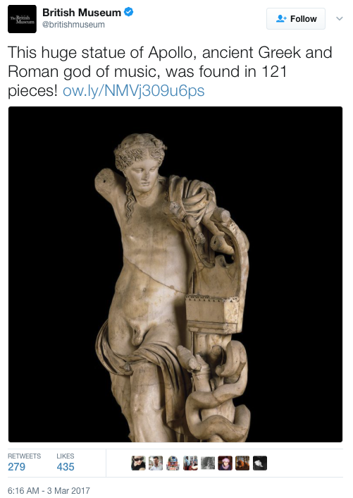

Appendix 2, Selected

2.1 | 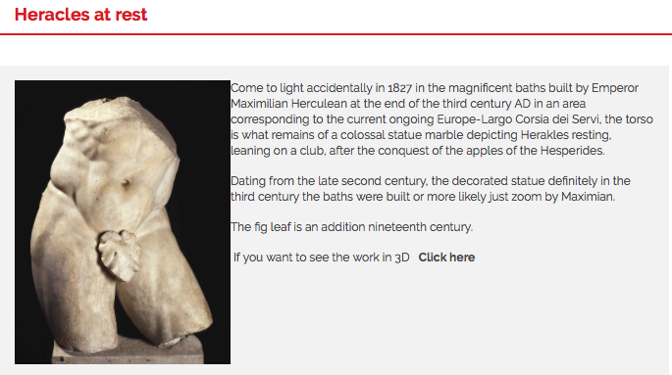
2.2 | 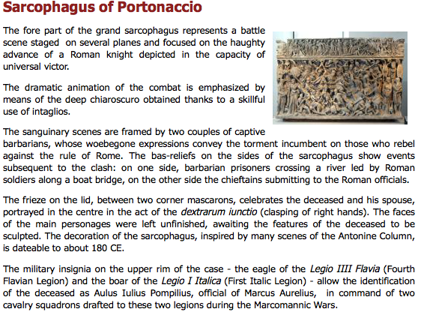
2.3 | 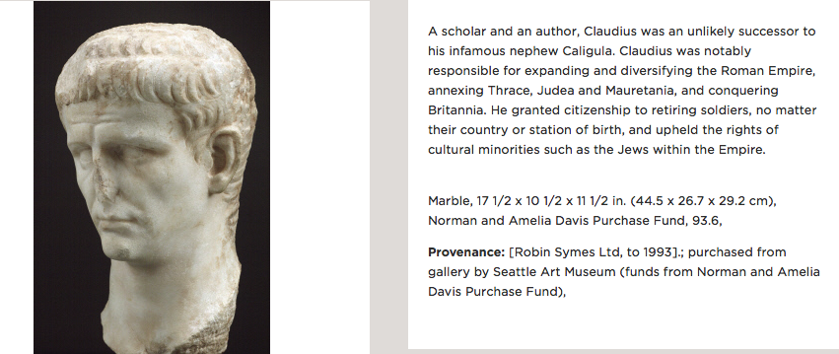
2.4 | 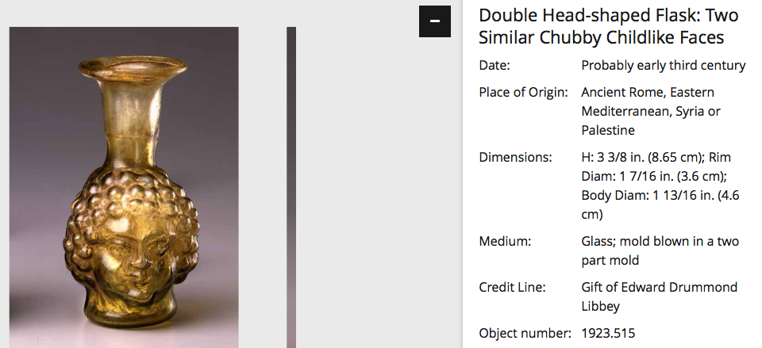

Appendix 3, Selected
3.1
3.2 | 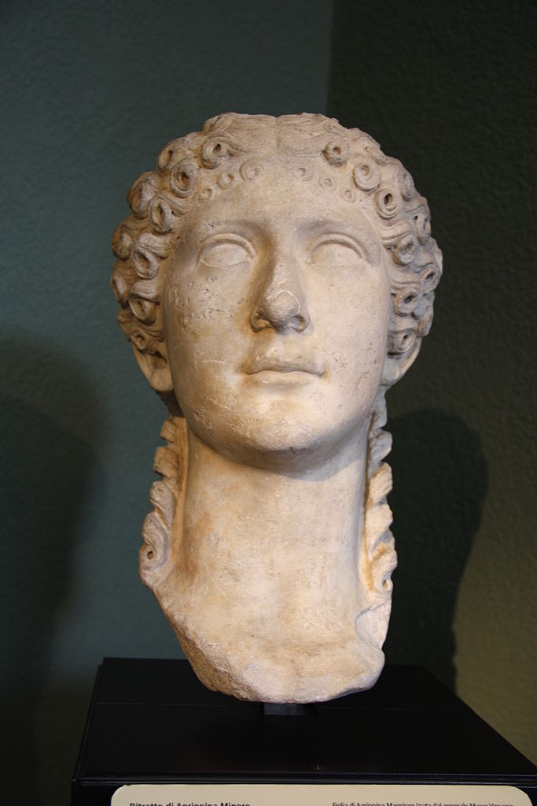
3.3 | 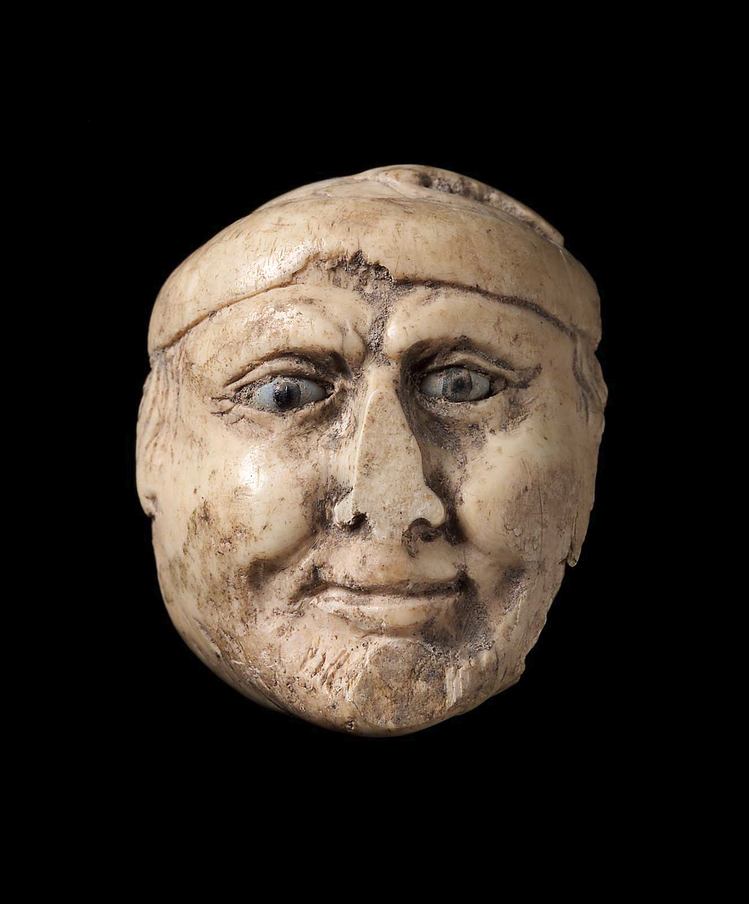
3.4 | 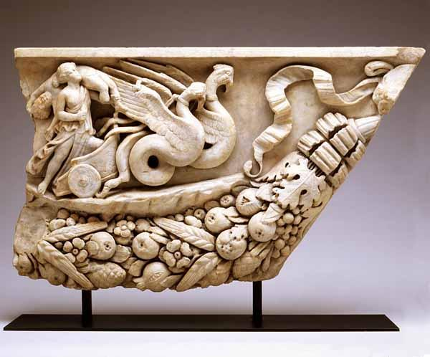
3.5 | 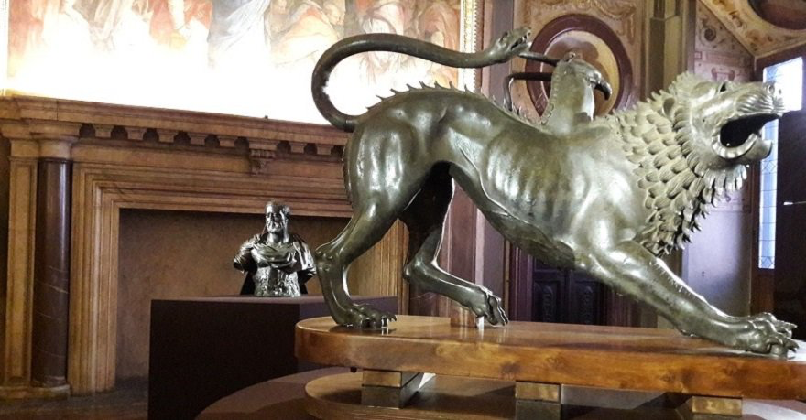
3.6 | 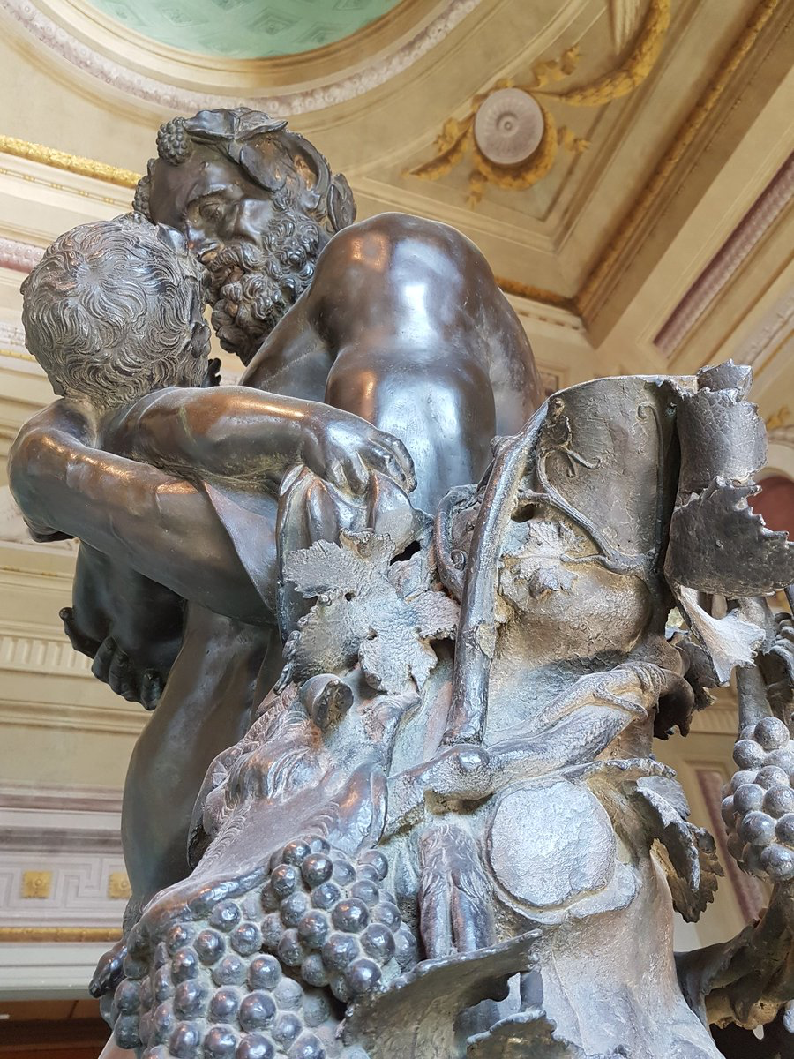
3.7 | 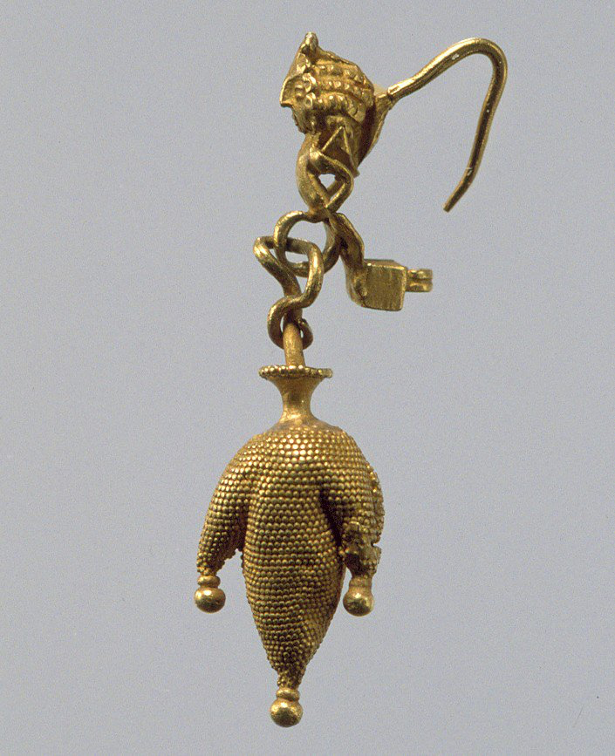
3.8 | 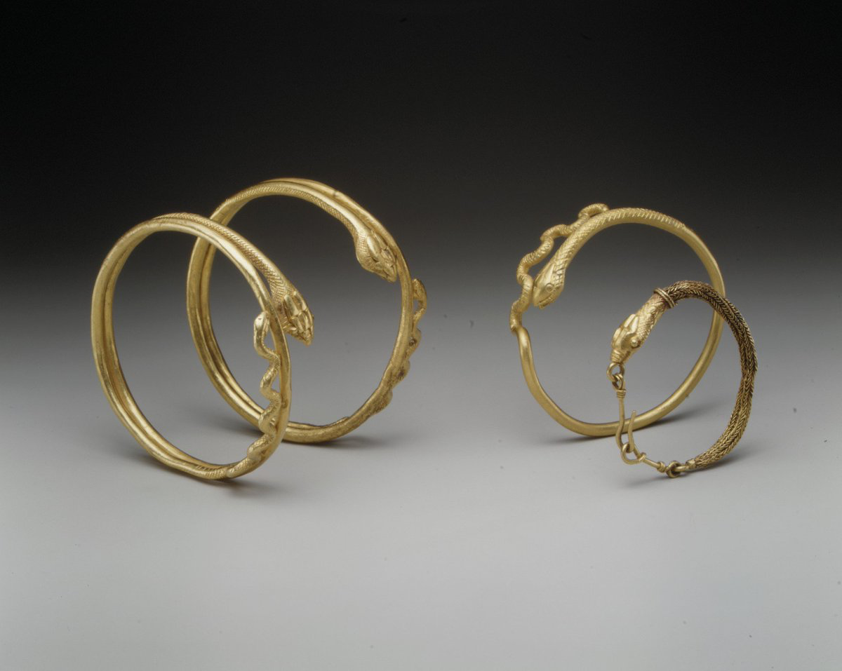

Raisa E. Patron. "The Looting of Iraqi Archaeological Sites: Global Implications and Support for an International Approach to Regulating the Antiquities Market," The George Washington International Law Review 40, no. 2 (September 2008), 473.
United Nations Educational, Scientific and cultural Organization (UNESCO). The Fight against the Illicit Trafficking of Cultural Objects: The 1970 Convention: Past and Future. Paris: UNESCO, 2011.
Ibid.
Embassy of the United States and Rome. "Agreement Between the Government of the United States of America and the Government of the Republic of Italy Concerning the Imposition of Import Restrictions on Categories of Archaeological Material Representing the Pre-Classical, Classical, and Imperial Roman Periods of Italy," Agreement. 16-112. (Washington, DC: 19 January 2001), 1-3; Embassy of Egypt and Rome. "Agreement on the Cultural and Historical Property Between the Government of the Arab Republic of Egypt and the Government of the Italian Republic in the Field of Protection and Repatriation of Cultural Property," Agreement. 003906-8554424. (Rome, Italy and Egypt: 6 September 2008), 9-13.
United Nations Educational, Scientific, and Cultural Organization. “Return or Restitution Cases,” Restitution of Cultural Property, <http://www.unesco.org/new/en/culture/themes/restitution-of-cultural-property/return-or-restitution-cases/> (Accessed: 12 November 2016); United Nations Educational, Scientific, and Cultural Organization. “Recent Examples of Successful Operations of Cultural Property Restitutions in the World,” Restitution of Cultural Property, <http://www.unesco.org/new/en/culture/themes/restitution-of-cultural-property/successful-restitutions-in-the-world/> (Accessed: 12 November 2016); United Nations Educational, Scientific, and Cultural Organization. “Other Cases of Return or Restitution of Cultural Objects,” Illicit Trafficking of Cultural Property, < http://www.unesco.org/new/en/culture/themes/illicit-trafficking-of-cultural-property/other-cases-of-return-or-restitution-of-cultural-objects/> (Accessed: 12 November 2016).
Patron, 470; Tess Davis. "Supply and Demand: Exposing the Illicit Trade in Cambodian Antiquities through a Study of Sotheby’s Auction House," Crime, Law and Social Change 56, no. 2 (2011), 155.
Patron, 472; Paul Wood. "Display, Restitution and World Art History: The Case of the ‘Benin Bronzes’, "Visual Culture in Britain 13, no. 1 (2012), 121.
UNESCO. The Fight; Davis, 159; Leila Amineddoleh. "The Role of Museums in the Trade of Black Market Cultural Heritage Property," Art, Antiquity & Law 18, no. 3 (October 2013), 223; Simon R. M Mackenzie. "Dig a Bit Deeper: Law, Regulation and the Illicit Antiquities Market," The British Journal of Criminology 45, no. 3 (2005), 265.
UNESCO. The Fight; Patron, 471.
Patron, 471.
Timothy J. Moore. “Australian Illicit Drug Market Data: Sources and Issues,” Australian Economic Review 39, no. 4 (2006), 442-452; David A. Bright and Alison Ritter. “Retail Price as an Outcome Measure for the Effectiveness of Drug Law Enforcement,” International Journal of Drug Policy 21, no. 5 (September 2010), 359-363.
See Davis as an example.
Patron, 470; Davis, 155.
Patron, 470; Davis, 155.
Ibid.
Patron, 482; Mackenzie, 252.
Davis, 172; Donna Yates. “Church Theft, Insecurity, and Community Justice: The Reality of Source-End Regulation of the Market for Illicit Bolivian Cultural Objects,” European Journal on Criminal Policy and Research 20, no. 20 (December 2014), 445-457; Amineddoleh, 248.
Ibid., 475.
Amineddoleh, 248.
Patron, 472-473; Wood, 121; Lawrence Rothfield. The Rape of Mesopotamia: Behind the Looting of the Iraq Museum. (Chicago: University of Chicago Press, 2009), 25-26.
Davis, 168; Patron, 473.
Wood, 115.
Wood, 121; Patron, 473.
Ibid.
Wood, 135; Amineddoleh, 227; Robin Francis Rhodes. The Acquisition and Exhibition of Classical Antiquities: Professional, Legal, and Ethical Perspectives. Notre Dame: University of Notre Dame Press, 2007, 11.
Rhodes, 11.
Patron, 479.
Wood, 121.
Rhodes, 19.
Amineddoleh, 227-54; David Keane and Valentina Azarov. "UNESCO, Palestine and Archaeology in Conflict." Denver Journal of International Law and Policy, (Spring 2013); Christa Roodt. "Restitution of Art and Cultural Objects and Its Limits." The Comparative and International Law Journal of Southern Africa 46, no. 3 (2013), 286- 307; Davis, 155; Patron, 465-496; Cameron Semmes Stoll. "The Effects of Judicial Decisions and Patrimony Laws on the Price of Italian Antiquities," International Journal of Cultural Property 19, no. 1 (February 2012), 65-96; Amineddoleh, 227-254.
UNESCO, The Fight; Davis, 159; Amineddoleh, 223.
Amineddoleh, 223; Mackenzie, 265.
Roodt, 294; Keane, 343; Amineddoleh, 242.
UNESCO, The Fight; Davis, 159; Amineddoleh, 223.
UNESCO, The Fight.
Davis, 159.
Roodt, 307.
Roodt, 307.
Stoll, 91.
Keane, 309; Patron, 484.
Amineddoleh, 223; Mackenzie, 265.
Mackenzie, 250.
Ibid., 265.
Roodt, 293; Davis, 163.
Denis Mack Smith. Modern Italy: A Political History. Ann Arbor: University of Michigan Press, 1997.
Amineddoleh, 244.
Ali Ersen Erol. “’Please Don’t Be Turk, BE GREEK, BE ARMENIAN’ Agency and Deixis Across Virtualized Turkish Imagined Community,” International Journal of Communication 7, (2013), 743.
Amineddoleh, 244.
The United States of America and Italy. “Memorandum of Understanding: Cultural Property,” 13 January 2006.
A good example of social media analysis: Tobias Denskus and Daniel E. Esser. “Social Media and Global Development Rituals: A Content Analysis of Blogs and Tweets on the 2010 MDG Summit,” Third World Quarterly 34, no. 3 (May 2013), 405-422.
Jeruen E. Dery and Dagmar Bittner. “Time and Causation in Discourse: Temporal Proximity, Implicit Causality, and Re-mention Biases,” Journal of Psycholinguistic Research 45, no. 4 (June 2015), 884.
Gillian Rose. Visual Methodologies: An Introduction to the Interpretation of Visual Materials. London: Sage, 2001, 6.
Katie Bresner. "Sharing Identity through Indingenous Tourism: Osoyoos Indian Band's Nk'Mip Desert Cultural Centre," Anthropoligica 56, no. 1 (2014), 140; Marcus Banks. Visual Methods in Social Research, 1. London: Sage, 2001, 11.
Carey Jewitt. "A Social Semiotic Analysis of Male Heterosexuality in Sexual Health Resources: the Case of Images" cited in: Jewitt, Carey and Rumiko Oyama. Visual Meaning: a Social Semiotic Approach: The Handbook of Visual Analysis. Cape Town: SAGE Publications, Inc., 2012; Nicki Lisa Cole. “Global Capitalism Organizing Knowledge of Race, Gender, and Class: The Case of Responsible Coffee,” Race, Gender, and Class 15, no. 1 (2008), 170-187.
Anabela da Conceicao Pereira. “Contrasting (Power of) Visual and Textual Discourses In Art Studies: a Critical Perspective,” Visual Communication 15, no. 1 (2015), 39.
Bresner, 140.
A model for discourse analysis of key words and phrases: McGuirk, Siobhan. “’God Loves You and It Gets Better’ Ideology, Deixis, and Agency in an Anti-Homophobic Bullying Viral Campaign,” Journal of Language and Sexuality 3, no. 2 (2014), 219-244.
Arma dei Carabinieri. "#Carabinieri the #TPC Recovered," Twitter, 5 December 2016, <https://twitter.com/_Carabinieri_/status/805801671184044032> (6 December 2016); FBI. “Love.”
Appendix 1.10
Peregrine Shwartz-Shea and Dvora Yanow. Interpretive Research Design: Concepts and Processes, edition 1. (New York and London: Routledge, 2011), 86. The authors loosely define intertextuality as an interaction between texts with shared meaning making.
Iver B. Neumann defines cultural competence as “an in-depth knowledge of a certain context that can include language or familiarity with cultural nuances” in his article: Iver B. Neumann. “Discourse Analysis,” in Qualitative Methods in International Relations, ed. Audie Klotz and Deepa Prakash (Great Britain: Palgrave MacMillan, 2008), 63-64.
Bugra Zengin and Isil Gunseli Kacar. “Turkish EFL Academicians’ Problems Concerning Translation Activities and Practices, Attitudes Towards the Use of Online and Printed Translation Tools, And Suggestions for Quality Translation Practice,” The Turkish Online Journal of Educational Technology 10, no. 2 (April 2011), 274.
Schwartz-Shea and Yanow define reflexivity as the systematic consideration of a researcher’s characteristics in their article; Schwartz-Shea and Yanow, 78-114.
Shwartz-Shea and Yanow, 78-114.
These steps are: bottom up development, relevance of researcher identity, ability to improvise, and data-cogeneration; Ibid., 99.
Federal Bureau of Investigation. "Art Theft," What We Investigate, <https://www.fbi.gov/investigate/violent crime/art-theft> (4 December 2016); Federal Bureau of Investigation. "FBI Art Theft Program," YouTube, 18 March 2013, <https://www.youtube.com/watch?v=f4HHYXS2MUE&feature=youtu.be> (3 December 2016); Federal Bureau of Investigation. “FBI New York Hosts Italian Carabinieri in Formal Ceremony to Return Roman Statue Stolen 33 Years Ago,” News, < https://www.fbi.gov/contact-us/field-offices/newyork/news/press-releases/fbi-new-york-hosts-italian-carabinieri-in-formal-ceremony-to-return-roman-statue-stolen-33-years-ago> (Accessed: 13 January 2017).
Appendix 1.8
Appendix 1.3
Shwartz-Shea and Yanow, 86. The authors loosely define intertextuality as an interaction between texts with shared meaning making.
Appendix 1.1 – 1.2
Appendix 1.3
Example: Appendix 1.4
Appendix 2.1 – 2.2
Museo Nazionale Romano. “Sarcophagus of Portanaccio,” < http://www.archeorm.arti.beniculturali.it/en/national-roman-museum-palazzo-massimo-alle-terme/sculptures/sarcophagus-portonaccio> (Accessed: 23 March 2017).
See Appendix 2.3 – 2.4
Data from 37 individual webpages such as: The Museum of Fine Art Boston. “Torso of a young god or athlete,” Art, < http://www.mfa.org/collections/object/torso-of-a-young-god-or-athlete-3> (Accessed: 20 March 2017); The Metropolitan Museum of Art. “Bronze statue of an aristocratic boy,” < http://www.metmuseum.org/art/collection/search/248891?sortBy=Relevance&amp;ft=roman&amp;offset=0&amp;rpp=20&amp;pos=3> (Accessed: 21 March 2017).
Appendix 3.1 - 3.4.
Appendix 3.5 - 3.6.
Appendix 3.7 - 3.8.
Keane, 309; Patron, 484; Amineddoleh, 223; Mackenzie, 265.
Keane, 309; Patron, 484; Amineddoleh, 223; Mackenzie, 265.
Rhodes, 11; Wood, 115; Patron, 470; Davis, 155.
Keane Azarov, 310-315; Davis, 168.
Davis, 168; Patron, 473.
Amineddoleh, 244.
Amineddoleh, 248.
Davis, 165.
Amineddoleh, 244; Davis 172; Mackenzie, 244.
Michael Balter. “University Suppresses Report on Provenance of Iraqi Antiquities,” Science 318, no. 5850 (October 2007), 554-555.
Davis, 165-166.
Davis, 159; Mackenzie, 250.
The United States of America and Italy. “Memorandum of Understanding: Cultural Property,” 13 January 2006.
Mackenzie, 265.
“Check out,” Twitter, <https://twitter.com/HeritageAtState/status/605695505797120000> (Accessed: 12 November 2016); Heritage at State. “#TBT @ICEgov,” Twitter, < https://twitter.com/HeritageAtState/status/718061491644145665> (Accessed: 10 November 2016)
FBI New York. “#FBI hosts,” Twitter, <https://twitter.com/NewYorkFBI/status/806593008766304256> (Accessed: 18 December 2016).
ARCA. “On the repatriation,” Twitter, < https://twitter.com/ARCA_artcrime/status/807194694530777088> (Accessed: 14 January 2017).
Heritage at State. “Effective today,” Twitter, <https://twitter.com/HeritageAtState/status/689605894485721088> (Accessed: 19 January 2017)
Arma dei Carabinieri. "#Carabinieri del #TPC Recovered," Twitter, 5 December 2016, <https://twitter.com/_Carabinieri_/status/805801671184044032> (6 December 2016). Translated by Bing.
Federal Bureau of Investigation. "Love #art?" Twitter, 7 November 2016, <https://twitter.com/FBI/status/795636546653147138> (6 December 2016).
Heritage at State. "Since its inception @FBD Art Crime Team," Twitter, 14 October 2016, <https://twitter.com/HeritageAtState/status/787027970410024960 > (6 December 2016).
Heritage at State. “In case,” Twitter, https://twitter.com/HeritageAtState/status/817011645625016325 (Accessed: 6 December 2016).
Onultalia. “Ancient statue stolen from #Rome,” Twitter, 8 December 2016, < https://twitter.com/Onuitalia/status/806853593806553088> (Accessed: 25 February 2017).
The British Museum. “This huge statue,” Twitter, 3 March 2017, < https://twitter.com/britishmuseum/status/837622696145989633> (Accessed: 3 March 2017).
Civico Museo Archeologico. “Heracles at rest,” <http://www.museoarcheologicomilano.it/wps/portal/poc?urile=wcm%3Apath%3ATUR_IT_ContentLibrary/minisito_museo_archeologico/lecollezioni/Milanoromana/Eracle_in_riposo> (Accessed: 14 January 2017).
Museo Nazionale Romano. “Sarcophagus of Portanaccio,” <http://www.ar cheorm.arti.beniculturali.it/en/national-roman-museum-palazzo-massimo-alle-terme/sculptures/sarcophagus-portonaccio> (Accessed: 14 January 2017).
Seattle Art Museum. “Posthumous Portrait Head Of The Emperor Claudius,” < http://www1.seattleartmuseum.org/eMuseum/code/emuseum.asp?collection=27210&collectionname=WEB:Ancient%20Mediterranean&style=browse&currentrecord=1&page=collection&profile=objects&searchdesc=WEB:Ancient%20Mediterranean&newvalues=1&newstyle=single&newcurrentrecord=1> (Accessed: 14 January 2017).
Toledo Museum. “Double Head-shaped Flask: Two Similar Chubby Childlike Faces,” < http://emuseum.toledomuseum.org:8080/emuseum/objects/52535/double-headshaped-flask-two-similar-chubby-childlike-faces?ctx=e3ccf326-f38f-4548-a5b4-4ee224ee58e1&idx=75> (Accessed: 14 January 2017).
The Museo Nazionale Romano. “Dying Niobid,” <http://www.archeorm.arti.beniculturali.it/en/ national-roman-museum-palazzo-massimo-alle-terme/sculptures/dying-niobid> (Accessed: 14 January 2017).
The Civico Museo Archeologico. “Portrait of Agrippina the Younger,” <http://www.museoarcheologicomilano.it/wps/portal/poc?urile=wcm%3Apath%3ATUR_IT_ContentLibrary/minisito_museo_archeologico/lecollezioni/milanoromana/Rit ratto_di_Agrippina_Minore> (Accessed: 14 January 2017).
The Museum of Fine Arts. “Face of an old man,” < http://www.mfa.org/collections/object/face-of-an-old-man-180744> (Accessed: 14 January 2017).
The Toledo Museum. “Fragment of a Sarcophagus,” < http://emuseum.toledomuseum.org:8080/emuseum/objects/60360/fragment-of- a-sarcophagus-medea?ctx=850c44cc-5505-44f7-b2f0-934a8c71473c&idx=130> (Accessed: 14 January 2017).
Galleri Uffizi. “Busto,” Twitter, < https://twitter.com/UffiziGalleries/status/847014783002066944> (Accessed: 14 January 2017).
Gallerie Uffizi. “Nell’assoluto,” Twitter, < https://twitter.com/Uffizi Galleries/status/846970740230508544> (Accessed: 14 January 2017). Translated by Bing.
The Metropolitan Museum of Art. “This earring,” Twitter, <https://twitter.com/metmuseum/status/813611666357227522> (Accessed: 14 January 2017).
The Metropolitan Museum of Art. “This gold,” Twitter, <https://twitter.com/metmuseum/status/701996202942971904> (Accessed: 14 January 2017).

