Paola Quinones

Prof. Connaughton

Vertebrate Physiology Lab

September 18, 2018

Abstract Lab 2: Neurophysiology

Action potentials are generated in response to a stimulus and are vital for the function of the human body. The purpose of this lab is to study nerve cell activity by examining action potentials and how their generation changes when being manipulated. Moreover, the speed of action potentials and the roles of sodium, threshold, and refractory period are also examined in order to fully understand cell activity. The experiments will provide real time measurement of action potential in a live animal, in this case, the discoid cockroach. First, a cockroach was put in iced water in order to anesthetize it and once it stopped moving, about 5 minutes after, it was removed from the water. One of the cockroach’s posterior leg was cut off and placed in the cork of the SpikerBox. The SpikerBox and the computer were set up and tested. For experiment one, different stimulation methods were used to touch and poke different areas of the leg in order to see the reactions in terms of action potentials. For experiment two, stimulation was done by blowing on the leg through a straw at different distances in order to identify the relationship between strength of stimulus and response (action potential). Lastly, the effect of temperature on action potential generation was tested. First, the SpikerBox/cockroach leg preparation was placed in the freezer and action potentials were observed. Then, it was taken out and left until it reached to room temperature. To see the effect of warm temperature, the SpikerBox/cockroach leg preparation was placed on top of a Styrofoam box and a candle was placed next to the leg. The change in action potentials was recorded as the temperature rose. Table 1 summarizes experiment 1: the stimulation methods, observations, the RMS of the base, action potential (AP), and the difference between them. Toothpick stimulation on the femur produces the most action potentials, and therefore, the most responses because it was the one with the most frequent AP and the biggest RMS difference. Figure 1 depicts the difference RMS values generated with different stimulation methods. Figure 2 shows the picture of the action potentials when the toothpick is stimulated on the femur; it shows frequent action potentials which can be used to conclude that the femur is a very sensitive area. Table 2, for experiment 2, shows that as the straw was closer to the leg (inches decreased), the stimulus was stronger and there was a greater action potential response, as seen in 35 psi (4 inches) which has the biggest RMS value (1.3). Figure 3 depicts the difference in RMS between different distances. Lastly, for experiment 3, it was seen that both changes in temperature, hot and cold, produced an increased response in action potentials, but after a while, the action potentials decreased and returned to baseline. This is because at first, there is a sudden change and the action potentials fire in response, after a while, the body gets used to the temperature and therefore, it is no longer a stimulus. In conclusion, action potentials respond to a stimulus and as seen on the experiments, the response and magnitude of action potentials is caused by sensitivity in the area being stimulated, strength of stimulus and prevalence of stimulus. It’s important to understand this process and how a stimulus can affect how our body responds to it.

Stimulation Methods | Observations | Spike RMS
None | Base, no spike | Base RMS = 1
Toothpick on tibia | Spaced out AP, not big | Base RMS = 1.44  AP RMS = 2.48  Difference RMS = 1.04
Toothpick on femur | Frequent, think, small AP | Base RMS = 0.76  AP RMS = 2.3  Difference RMS = 1.54
Blowing straw on tibia | Few, wide AP | Base RMS = 0.77  AP RMS 1.6  Difference RMS = 0.83
Toothpick on coccyx | Few, small, thin AP | Base RMS = 0.6  AP RMS = 1.5  Difference RMS = 0.9
Table 1: Stimulation Methods. Different stimulation methods on different areas of the leg in order to generate distinct responses. The toothpick on the femur generated the strongest action potentials while blowing with a straw on the tibia generated the weakest action potentials.

Figure 1: RMS Values with Distinct Stimulus. The RMS difference values for each stimulus graphed. It’s clear that the biggest value and therefore, the strongest action potentials were generated when the toothpick stimulated the femur.

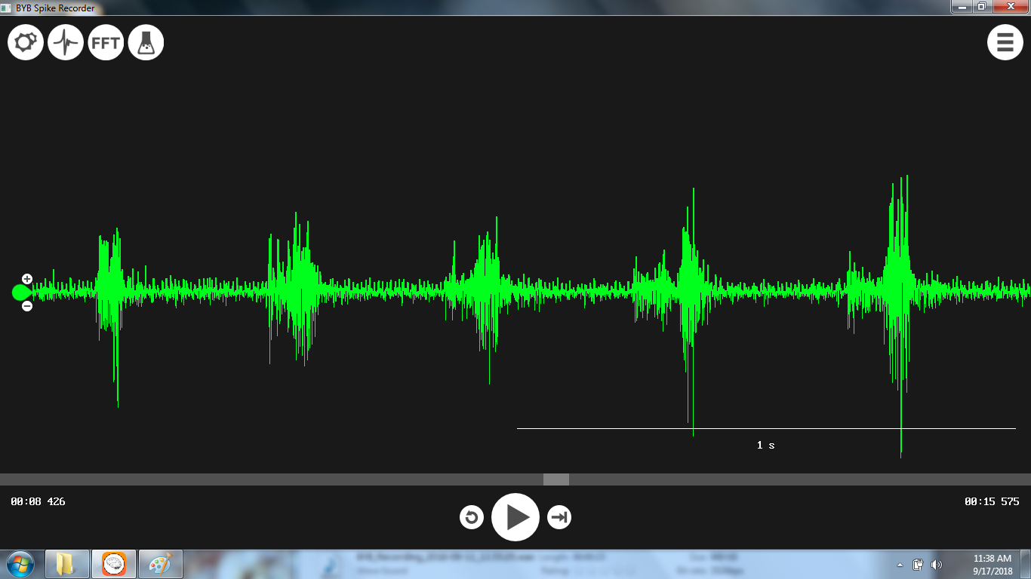
Figure 2: Toothpick on femur. In this figure, the baseline can be seen, the straight lines between the spikes. The spikes are the action potentials generated from the stimulus, in this case, the toothpick touching the femur.

Condition | Method Notes | Observations
No stimulation | No blowing | RMS = 1
5 psi (10 inches away) | Blew on straw. No AP | Base RMS = 1  AP RMS = 1.6  Difference RMS = 0.6
15 psi (8 inches away) | Blew on straw, slight change in AP | Base RMS = 1  AP RMS = 1.7  Difference RMS = 0.7
25 psi (6 inches away) | Blew on straw. Stronger AP but not as acute/frequent | Base RMS = 1  AP RMS = 2  Difference RMS = 1
35 psi (4 inches away) | Blew on straw. Wider AP. | Base RMS = 0.7  AP RMS = 2  Difference RMS = 1.3
Table 2: Strength of Stimulus and Action Potential Response. Closeness of the straw increased the stimulus strength and changed AP response. In this case, blowing the straw four inches away caused the greatest RMS difference and generated the strongest action potentials.

Figure 3: RMS of Different Strength of Stimulus. As the psi number gets bigger (inches get smaller) the stimulus gets progressively stronger, as depicted on the graph. It can be seen how the bars keep getting longer and longer.

